# Load the required libraries

library(readr)

library(ggplot2)

# Load the dataset 'projectdata.csv' and call it p

p = read.csv("C:\\Users\\i340968\\Desktop\\ed-code\\R_programming-elective\\projectdata.csv")

# Look at the structure of the dataset

str(p)

# Change the description variable from factor to character

p$description = as.character(p$description)

# Re-look at the structure of the dataset

str(p)

# Explore the data - which variables have missing values and what is the count of these missing values

summary(p)

#check the number of unique values in each column

apply(p,2,function(x) length(unique(x)))

# what is the median price

median(p$startprice)

#add a variable priceclass, which takes value 1 if the price is above median value, or 0 otherwise

p$priceclass <- ifelse(p$startprice>=170.5, 1, 0)

# Re-look at the structure of the dataset

str(p)

#convert categorical variables to factor

cols = c("biddable", "sold", "priceclass")

for(i in cols){

p[,i]=as.factor(p[,i])

}

# Re-Check structure

str(p)

# Find Maximum value of all numerical variables

apply(p[,c(3,8)], 2, max, na.rm= TRUE)

# Find Maximum value of all categorical variables

apply(p[,c(4:7, 9,10,12)], 2, max, na.rm= TRUE)

# use lapply function to Calculate Median of each of the numerical variables

lapply(p[,c(3,8)], function(x) median(x, na.rm = TRUE))

# use lapply function to Calculate standard deviation of each of the numerical variables

lapply(p[,c(3,8)], function(x) sd(x, na.rm = TRUE))

# use the tapply function to calculate the median price according to sold

tapply(p$startprice,p$sold,median)

# use the tapply function to calculate the median price according to biddable

tapply(p$startprice,p$biddable,median)

# Load the dplyr package

library(dplyr)

# Print out a df with the columns startprice, condition, and sold.

select(p, startprice, condition, sold)

# Print out the columns biddable to sold

select(p, biddable:sold)

#mutate

# Add the new variable var1 which calculates the ratio of storage to startprice and save the result in p.

p <- mutate(p, var1 = startprice/storage)

# Arrange p by price

arrange(p, startprice)

# Arrange p so that condition is grouped

arrange(p, condition)

# Arrange p so that biddable and sold is is grouped

arrange(p, biddable,sold)

# Definition of notbought - create a df of observations when ipad was notpurchased

notbought <- filter(p, sold == "1")

# Arrange notbought so that condition and sold is is grouped

arrange(notbought, condition, sold)

# Generate summary about startprice column of p

summarise(p,

minimum = min(startprice),

average = mean(startprice),

max = max(startprice),

sd = sd(startprice),

inter = IQR(startprice))

# Generate summary about storage column of housing

summarise(p,

minimum = min(storage),

average = mean(storage),

max = max(storage),

sd = sd(storage),

inter = IQR(storage))

#### Visualization ###

# Load the necessary package

library(ggplot2)

# Create a scatter plot between startprice and storage

ggplot(p, aes(x = storage, y = startprice)) +

geom_point()

# In the above plot, add the color argument which should be dependent on the sold Variable

ggplot(p, aes(x = storage, y = startprice, color = sold)) +

geom_point()

# In the above plot where you had used the color argument, please add the smooth line using the geom_smooth() function

ggplot(p, aes(x = storage, y = startprice, color = sold)) +

geom_point() +

geom_smooth()

# Make a univariate histogram on startprice

ggplot(p, aes(startprice)) +

geom_histogram()

# In the above plot, add set binwidth to 200 in the geom layer

ggplot(p, aes(startprice)) +

geom_histogram(binwidth = 200)

# In the above plot, MAP ..density.. to the y aesthetic (i.e. in a second aes() function)

ggplot(p, aes(startprice)) +

geom_histogram(aes(y = ..density..), binwidth = 200)

# Now, In the above plot, plus SET the fill attribute to "#377EB8"

ggplot(p, aes(startprice)) +

geom_histogram(aes(y = ..density..), binwidth = 200, fill = "#377EB8")

# Draw a bar plot of sold, filled according to biddable

ggplot(p, aes(x = sold, fill = biddable)) +

geom_bar()

# In the previous plot, Change the position argument to "stack""

ggplot(p, aes(x = sold, fill = biddable)) +

geom_bar(position = "stack")

# Change the position argument to "fill""

ggplot(p, aes(x = sold, fill = biddable)) +

geom_bar(position = "fill")

# Change the position argument to "dodge""

ggplot(p, aes(x = sold, fill = biddable)) +

geom_bar(position = "dodge")

##Faceting

# Now create a basic scatter plot between pce and psavert variables on econ_2:

p2 <- ggplot(p, aes(x = storage, y = startprice)) +

geom_point()

# Separate rows according to sold

p2 +

facet_grid(sold ~ .)

# Separate columns according to biddable

p2 +

facet_grid(. ~ biddable)

# Separate by both columns and rows

p2 +

facet_grid(sold ~ biddable)

### Text Analytics ###

#load the required packages and libraries

library(tm)

library(SnowballC)

library('stringr')

library('readr')

library('wordcloud')

library('tm')

library('SnowballC')

library(DT)

#Now, extract the relevant variable, the one containing the text.

r1 = as.character(p$description)

#Set the seed to 100 for code reproducibility

set.seed(100)

# run the following command, 'sample = sample(r1, (length(r1)))', in your RStudio, now you are ready for Bag of Words

sample = sample(r1, (length(r1)))

#Data Preprocessing using Bag of Words Technique

# Create a Corpus - which, in simple terms, is nothing but a collection of text documents.

corpus = Corpus(VectorSource(list(sample)))

# Now, remove punctuations

corpus = tm_map(corpus, removePunctuation)

# Next, change the case of the word to lowercase so that same words are not counted as different because of lower or upper case.

corpus = tm_map(corpus, content_transformer(tolower))

# Next, remove numbers

corpus = tm_map(corpus, removeNumbers)

# Next, remove whitespaces

corpus = tm_map(corpus, stripWhitespace)

# Now, remove unhelpful terms, also referred as stopwords

corpus = tm_map(corpus, removeWords, stopwords('english'))

# Now, please carry out the process of stemming, motivated by the desire to represent words with different endings as the same word.

corpus = tm_map(corpus, stemDocument)

# creat a document term matrix from the corpus

frequencies = DocumentTermMatrix(corpus)

# now create the data frame from the output of the above line

alldescription = as.data.frame(as.matrix(frequencies))

# Create a word cloud and set random.order = TRUE:

wordcloud(colnames(alldescription), colSums(alldescription), random.order=TRUE)

# Create a word cloud and set random.order = FALSE:

wordcloud(colnames(alldescription), colSums(alldescription), random.order=FALSE)

# In the above word cloud, adjust the frequency level with min.freq parameter set at 5

wordcloud(colnames(alldescription), colSums(alldescription), random.order=FALSE, min.freq=5)

##### Creating Word Cloud for Soldipads ####

#craete a new dataframe from the original data 'p' which only includes those observations where the ipad was not sold

notsoldipads = subset(p, sold == 0)

#Run the follwoing commands in your R Studio

#extracting relevant negative tweets as character

n1 = as.character(notsoldipads$description)

#Set the seed to 100 for code reproducibility

set.seed(100)

#sample

sample2 = sample(n1, (length(n1)))

#Bag of Words - Run the above codes

#1 - Create a Corpus

#2 - Remove punctuations

#3 - Convert to lowercase

#4 - Remove Numbers

#5 - Remove whitespaces

#6 - Remove stopwords

#7 - Perform Stemming

corpus2 = Corpus(VectorSource(list(sample2)))

corpus2 = tm_map(corpus2, removePunctuation)

corpus2 = tm_map(corpus2, content_transformer(tolower))

corpus2 = tm_map(corpus2, removeNumbers)

corpus2 = tm_map(corpus2, stripWhitespace)

corpus2 = tm_map(corpus2, removeWords, stopwords('english'))

corpus2 = tm_map(corpus2, stemDocument)

#creat a document term matrix from the resultant corpus

frequencies2 = DocumentTermMatrix(corpus2)

# now create the data frame from the output of the above line

notsold = as.data.frame(as.matrix(frequencies2))

# Create three word clouds using the following three instructions

# WordCloud 1 - Create a word cloud and set random.order = TRUE.

# WordCloud 2 - Create a word cloud and set random.order = FALSE

# WordCloud 3 - In the above word cloud, adjust the frequency level with min.freq parameter set at 5

wordcloud(colnames(notsold), colSums(notsold), random.order=TRUE)

wordcloud(colnames(notsold), colSums(notsold), random.order=FALSE)

wordcloud(colnames(notsold), colSums(notsold), random.order=FALSE, min.freq=5)

##### Creating Word Cloud for sold ipads ####

#craete a new dataframe from the original data 'p' which only includes those observations where the ipad was sold

p_sold = subset(p,sold == 1)

#Now, run the follwoing commands in your R Studio

#extracting relevant positive tweets

p1 = as.character(p_sold$description)

#Set the seed to 100 for code reproducibility

set.seed(100)

#sample

sample3 = sample(p1, (length(p1)))

#Bag of Words - Run the above codes

#1 - Create a Corpus

#2 - Remove punctuations

#3 - Convert to lowercase

#4 - Remove Numbers

#5 - Remove whitespaces

#6 - Remove stopwords

#7 - Perform Stemming

corpus3 = Corpus(VectorSource(list(sample3)))

corpus3 = tm_map(corpus3, removePunctuation)

corpus3 = tm_map(corpus3, content_transformer(tolower))

corpus3 = tm_map(corpus3, removeNumbers)

corpus3 = tm_map(corpus3, stripWhitespace)

corpus3 = tm_map(corpus3, removeWords, stopwords('english'))

corpus3 = tm_map(corpus3, stemDocument)

#creat a document term matrix from the resultant corpus

frequencies3 = DocumentTermMatrix(corpus3)

# now create the data frame from the output of the above line

soldipads = as.data.frame(as.matrix(frequencies3))

# Create three word clouds using the following three instructions

# WordCloud 1 - Create a word cloud and set random.order = TRUE.

# WordCloud 2 - Create a word cloud and set random.order = FALSE

# WordCloud 3 - In the above word cloud, adjust the frequency level with min.freq parameter set at 5

wordcloud(colnames(soldipads), colSums(soldipads), random.order=TRUE)

wordcloud(colnames(soldipads), colSums(soldipads), random.order=FALSE)

wordcloud(colnames(soldipads), colSums(soldipads), random.order=FALSE, min.freq=5)

Console:

==========

> # Load the required libraries

> library(readr)

> library(ggplot2)

> # Load the dataset 'projectdata.csv' and call it p

> p = read.csv("C:\\Users\\i340968\\Desktop\\ed-code\\R_programming-elective\\projectdata.csv")

> # Look at the structure of the dataset

> str(p)

'data.frame': 790 obs. of 11 variables:

$ description: Factor w/ 674 levels "#6428","&#034;Great Working Condition&#034;",..: 27 1 2 6 8 11 13 14 15 16 ...

$ biddable : int 0 0 1 0 0 0 0 0 0 0 ...

$ startprice : num 249.99 124.95 0.99 200.29 199.99 ...

$ condition : Factor w/ 5 levels "For parts or not working",..: 5 5 5 4 5 2 4 5 5 4 ...

$ cellular : Factor w/ 3 levels "0","1","Unknown": 1 1 2 1 3 2 2 1 1 2 ...

$ carrier : Factor w/ 7 levels "AT&T","None",..: 2 2 1 2 6 7 7 2 2 1 ...

$ color : Factor w/ 5 levels "Black","Gold",..: 3 4 5 1 4 1 1 1 5 1 ...

$ storage : int 16 16 16 16 16 16 16 16 16 16 ...

$ productline: Factor w/ 11 levels "iPad 1","iPad 2",..: 11 1 8 3 1 7 2 5 2 1 ...

$ sold : int 0 0 1 0 0 1 0 0 0 1 ...

$ UniqueID : int 11001 11207 10657 10949 11305 11514 10665 10877 11849 10068 ...

> # Change the description variable from factor to character

> p$description = as.character(p$description)

> # Re-look at the structure of the dataset

> str(p)

'data.frame': 790 obs. of 11 variables:

$ description: chr "99%" "#6428" "&#034;Great Working Condition&#034;" "*FREE* Same-Day Ship | 90-Day Warranty | 100% Functional, Includes All Major Accessories, Shows " ...

$ biddable : int 0 0 1 0 0 0 0 0 0 0 ...

$ startprice : num 249.99 124.95 0.99 200.29 199.99 ...

$ condition : Factor w/ 5 levels "For parts or not working",..: 5 5 5 4 5 2 4 5 5 4 ...

$ cellular : Factor w/ 3 levels "0","1","Unknown": 1 1 2 1 3 2 2 1 1 2 ...

$ carrier : Factor w/ 7 levels "AT&T","None",..: 2 2 1 2 6 7 7 2 2 1 ...

$ color : Factor w/ 5 levels "Black","Gold",..: 3 4 5 1 4 1 1 1 5 1 ...

$ storage : int 16 16 16 16 16 16 16 16 16 16 ...

$ productline: Factor w/ 11 levels "iPad 1","iPad 2",..: 11 1 8 3 1 7 2 5 2 1 ...

$ sold : int 0 0 1 0 0 1 0 0 0 1 ...

$ UniqueID : int 11001 11207 10657 10949 11305 11514 10665 10877 11849 10068 ...

> # Explore the data - which variables have missing values and what is the count of these missing values

> summary(p)

description biddable startprice condition cellular carrier

Length:790 Min. :0.0000 Min. : 0.01 For parts or not working: 93 0 :445 AT&T :111

Class :character 1st Qu.:0.0000 1st Qu.: 80.00 Manufacturer refurbished: 17 1 :246 None :448

Mode :character Median :0.0000 Median :170.50 New other (see details) : 47 Unknown: 99 Other : 2

Mean :0.4038 Mean :186.34 Seller refurbished : 73 Sprint : 9

3rd Qu.:1.0000 3rd Qu.:269.99 Used :560 T-Mobile: 11

Max. :1.0000 Max. :699.95 Unknown :134

Verizon : 75

color storage productline sold UniqueID

Black :177 Min. : 16.00 iPad 2 :149 Min. :0.0000 Min. :10001

Gold : 20 1st Qu.: 16.00 iPad 1 :104 1st Qu.:0.0000 1st Qu.:10490

Space Gray: 59 Median : 32.00 iPad mini:104 Median :0.0000 Median :10924

Unknown :340 Mean : 33.26 iPad Air : 87 Mean :0.4354 Mean :10934

White :194 3rd Qu.: 32.00 Unknown : 85 3rd Qu.:1.0000 3rd Qu.:11358

Max. :128.00 iPad 4 : 84 Max. :1.0000 Max. :11861

(Other) :177

> #check the number of unique values in each column

> apply(p,2,function(x) length(unique(x)))

description biddable startprice condition cellular carrier color storage productline sold

674 2 326 5 3 7 5 4 11 2

UniqueID

790

> # what is the median price

> median(p$startprice)

[1] 170.5

> #add a variable priceclass, which takes value 1 if the price is above median value, or 0 otherwise

> p$priceclass <- ifelse(p$startprice>=170.5, 1, 0)

> # Re-look at the structure of the dataset

> str(p)

'data.frame': 790 obs. of 12 variables:

$ description: chr "99%" "#6428" "&#034;Great Working Condition&#034;" "*FREE* Same-Day Ship | 90-Day Warranty | 100% Functional, Includes All Major Accessories, Shows " ...

$ biddable : int 0 0 1 0 0 0 0 0 0 0 ...

$ startprice : num 249.99 124.95 0.99 200.29 199.99 ...

$ condition : Factor w/ 5 levels "For parts or not working",..: 5 5 5 4 5 2 4 5 5 4 ...

$ cellular : Factor w/ 3 levels "0","1","Unknown": 1 1 2 1 3 2 2 1 1 2 ...

$ carrier : Factor w/ 7 levels "AT&T","None",..: 2 2 1 2 6 7 7 2 2 1 ...

$ color : Factor w/ 5 levels "Black","Gold",..: 3 4 5 1 4 1 1 1 5 1 ...

$ storage : int 16 16 16 16 16 16 16 16 16 16 ...

$ productline: Factor w/ 11 levels "iPad 1","iPad 2",..: 11 1 8 3 1 7 2 5 2 1 ...

$ sold : int 0 0 1 0 0 1 0 0 0 1 ...

$ UniqueID : int 11001 11207 10657 10949 11305 11514 10665 10877 11849 10068 ...

$ priceclass : num 1 0 0 1 1 1 0 1 0 0 ...

|  |
| --- |
| > #convert categorical variables to factor  > cols = c("biddable", "sold", "priceclass")  > for(i in cols){  + p[,i]=as.factor(p[,i])  + }  > # Re-Check structure  > str(p)  'data.frame': 790 obs. of 12 variables:  $ description: chr "99%" "#6428" "&#034;Great Working Condition&#034;" "*FREE* Same-Day Ship | 90-Day Warranty | 100% Functional, Includes All Major Accessories, Shows " ...  $ biddable : Factor w/ 2 levels "0","1": 1 1 2 1 1 1 1 1 1 1 ...  $ startprice : num 249.99 124.95 0.99 200.29 199.99 ...  $ condition : Factor w/ 5 levels "For parts or not working",..: 5 5 5 4 5 2 4 5 5 4 ...  $ cellular : Factor w/ 3 levels "0","1","Unknown": 1 1 2 1 3 2 2 1 1 2 ...  $ carrier : Factor w/ 7 levels "AT&T","None",..: 2 2 1 2 6 7 7 2 2 1 ...  $ color : Factor w/ 5 levels "Black","Gold",..: 3 4 5 1 4 1 1 1 5 1 ...  $ storage : int 16 16 16 16 16 16 16 16 16 16 ...  $ productline: Factor w/ 11 levels "iPad 1","iPad 2",..: 11 1 8 3 1 7 2 5 2 1 ...  $ sold : Factor w/ 2 levels "0","1": 1 1 2 1 1 2 1 1 1 2 ...  $ UniqueID : int 11001 11207 10657 10949 11305 11514 10665 10877 11849 10068 ...  $ priceclass : Factor w/ 2 levels "0","1": 2 1 1 2 2 2 1 2 1 1 ...  > # Find Maximum value of all numerical variables  > apply(p[,c(3,8)], 2, max, na.rm= TRUE)  startprice storage  699.95 128.00  > # Find Maximum value of all categorical variables  > apply(p[,c(4:7, 9,10,12)], 2, max, na.rm= TRUE)  condition cellular carrier color productline sold priceclass  "Used" "Unknown" "Verizon" "White" "Unknown" "1" "1"  > # use lapply function to Calculate Median of each of the numerical variables  > lapply(p[,c(3,8)], function(x) median(x, na.rm = TRUE))  $startprice  [1] 170.5  $storage  [1] 32  > # use lapply function to Calculate standard deviation of each of the numerical variables  > lapply(p[,c(3,8)], function(x) sd(x, na.rm = TRUE))  $startprice  [1] 139.6412  $storage  [1] 24.7185  > # use the tapply function to calculate the median price according to sold  > tapply(p$startprice,p$sold,median)  0 1  225.000 79.995  > # use the tapply function to calculate the median price according to biddable  > tapply(p$startprice,p$biddable,median)  0 1  220 75 |
|  |
| |  | | --- | | > | |

> # Load the dplyr package

> library(dplyr)

> # Print out a df with the columns startprice, condition, and sold.

> select(p, startprice, condition, sold)

startprice condition sold

1 249.99 Used 0

2 124.95 Used 0

3 0.99 Used 1

4 200.29 Seller refurbished 0

5 199.99 Used 0

6 219.00 Manufacturer refurbished 1

7 127.99 Seller refurbished 0

8 379.99 Used 0

9 164.99 Used 0

10 79.99 Seller refurbished 1

11 189.99 Used 0

12 39.99 Used 1

13 50.00 New other (see details) 1

14 76.00 Used 0

15 140.00 Used 0

16 80.00 Used 0

17 186.00 Used 0

18 288.00 Used 1

19 89.00 Used 0

20 171.00 Used 0

21 162.00 Used 0

22 227.00 Used 0

23 280.00 Used 0

24 160.00 For parts or not working 0

25 56.00 Used 1

26 70.00 Used 1

27 250.00 Used 1

28 500.00 Used 0

29 169.99 Used 0

30 100.00 Used 1

31 110.00 Used 0

32 250.00 Used 0

33 250.00 Used 0

34 200.00 Seller refurbished 0

35 250.00 Used 0

36 210.00 New other (see details) 0

37 199.99 New other (see details) 1

38 100.00 New other (see details) 1

39 449.00 New other (see details) 0

40 449.99 New other (see details) 0

41 340.00 New other (see details) 0

42 149.98 For parts or not working 0

43 29.95 For parts or not working 1

44 36.95 For parts or not working 1

45 36.95 For parts or not working 1

46 36.95 For parts or not working 1

47 36.95 For parts or not working 0

48 225.00 Used 0

49 261.99 Seller refurbished 0

50 237.99 Seller refurbished 0

51 257.83 Seller refurbished 0

52 274.99 Seller refurbished 0

53 0.99 Used 1

54 160.00 Used 1

55 49.99 Used 1

56 1.00 Used 1

57 250.00 Used 1

58 147.59 Used 1

59 174.99 Used 0

60 125.00 Used 1

61 155.00 For parts or not working 0

62 45.00 Used 1

63 5.00 Used 0

64 0.99 For parts or not working 1

65 200.00 Used 1

66 279.00 Used 1

67 90.00 Used 0

68 300.00 Manufacturer refurbished 0

69 99.95 For parts or not working 1

70 0.01 Used 1

71 250.00 Used 0

72 75.00 Used 1

73 99.99 Used 1

74 399.00 Used 0

75 0.99 Seller refurbished 1

76 200.00 Used 0

77 155.00 Used 1

78 100.00 New other (see details) 1

79 175.00 Used 0

80 149.95 Used 1

81 269.95 Used 0

82 199.99 Seller refurbished 0

83 85.00 For parts or not working 0

84 165.00 For parts or not working 0

85 0.99 Seller refurbished 1

86 0.99 Seller refurbished 1

87 129.99 Used 0

88 165.00 Used 0

89 0.99 Used 1

90 149.99 Used 1

91 149.00 Used 0

92 0.01 Used 1

93 0.01 Used 1

94 199.99 Used 1

95 99.99 Used 1

96 0.99 Used 1

97 0.99 Used 1

98 20.00 Used 1

99 149.00 Used 1

100 128.00 Used 1

101 99.99 Used 1

102 184.99 Used 1

103 199.00 Used 1

104 229.00 Used 0

105 209.85 Manufacturer refurbished 0

106 294.99 Manufacturer refurbished 0

107 239.00 Seller refurbished 1

108 249.99 Manufacturer refurbished 0

109 249.99 Manufacturer refurbished 0

110 134.95 Used 1

111 265.00 Used 0

112 100.00 Used 0

113 199.99 Seller refurbished 1

114 234.00 Used 0

115 75.00 Used 1

116 209.99 Used 0

117 0.01 Used 1

118 225.00 Used 0

119 150.00 Used 0

120 187.50 Used 0

121 187.50 Used 0

122 184.50 Used 1

123 187.50 Used 0

124 290.00 Used 0

125 100.00 Used 0

126 160.00 Used 0

127 259.00 New other (see details) 0

128 280.00 Used 1

129 270.99 Used 0

130 115.00 Used 1

131 289.95 Used 0

132 265.00 Used 0

133 1.00 Used 1

134 199.99 Used 1

135 100.00 Used 1

136 129.99 For parts or not working 0

137 49.95 Used 1

138 100.00 Used 1

139 299.99 Used 0

140 199.00 For parts or not working 0

141 0.01 Used 1

142 259.99 Used 0

143 349.99 Used 0

144 349.95 Used 0

145 146.99 Used 0

146 50.00 Used 0

147 320.00 Used 0

148 165.00 Used 0

149 115.00 Used 1

150 130.00 Used 1

151 220.00 Used 0

152 90.00 Used 1

153 0.99 Used 1

154 350.00 New other (see details) 0

155 0.99 Used 1

156 0.99 Used 1

157 119.99 Used 0

158 159.99 Used 0

159 66.99 For parts or not working 0

160 74.99 For parts or not working 0

161 399.99 Used 1

162 79.99 Used 1

163 0.99 Seller refurbished 1

164 249.99 Used 0

165 80.00 Used 0

166 149.99 Used 0

167 238.80 Used 0

168 0.99 For parts or not working 1

169 400.00 Used 0

170 0.99 Used 1

171 150.00 Used 0

172 198.00 Used 0

173 89.00 Used 1

174 0.99 Seller refurbished 1

175 319.00 New other (see details) 1

176 159.99 Used 0

177 111.50 Used 1

178 20.00 Used 1

179 149.99 Used 1

180 149.97 Used 0

181 249.59 Seller refurbished 0

182 149.98 Used 0

183 260.00 New other (see details) 1

184 0.99 Used 1

185 399.99 Used 0

186 292.50 Used 1

187 259.00 Used 0

188 350.00 Used 0

189 303.67 Used 0

190 199.99 Used 0

191 249.99 Manufacturer refurbished 0

192 201.99 Used 1

193 187.89 Used 0

194 99.99 Manufacturer refurbished 0

195 185.49 Used 0

196 525.00 Used 0

197 199.99 Used 0

198 0.99 New other (see details) 1

199 265.00 Used 0

200 70.00 Used 1

201 184.99 Seller refurbished 0

202 210.00 Used 0

203 225.00 Used 0

204 319.99 Used 0

205 199.99 Used 1

206 259.95 Used 0

207 220.00 Used 0

208 220.00 Used 0

209 150.00 Seller refurbished 0

210 0.99 Used 1

211 0.99 Used 1

212 199.99 Seller refurbished 1

213 350.00 New other (see details) 0

214 175.00 New other (see details) 0

215 100.00 Used 1

216 99.00 New other (see details) 1

217 0.01 Used 1

218 79.00 Used 0

219 175.00 Used 1

220 160.57 Used 1

221 185.00 Used 1

222 149.99 Seller refurbished 1

223 0.99 For parts or not working 1

224 0.99 For parts or not working 1

225 0.99 For parts or not working 1

226 175.00 Used 0

227 189.99 Used 1

228 199.00 Used 0

229 320.00 New other (see details) 0

230 210.00 Used 0

231 50.00 Used 1

232 150.00 Used 0

233 490.95 Used 0

234 279.99 New other (see details) 0

235 119.99 Used 0

236 89.50 Used 0

237 252.99 Manufacturer refurbished 0

238 300.00 Used 1

239 380.00 Used 0

240 259.99 Seller refurbished 0

241 0.99 For parts or not working 1

242 129.95 For parts or not working 0

243 394.99 Used 0

244 69.95 For parts or not working 0

245 29.99 For parts or not working 1

246 229.00 Used 0

247 0.99 Used 1

248 39.99 Used 1

249 200.00 Used 1

250 295.00 Used 1

251 0.99 Used 1

252 0.99 Used 1

253 119.99 Used 0

254 264.99 Manufacturer refurbished 0

255 157.00 For parts or not working 0

256 114.99 Used 1

257 0.99 Seller refurbished 1

258 160.00 Used 0

259 40.00 Used 1

260 100.00 Used 1

261 89.99 For parts or not working 0

262 100.00 For parts or not working 1

263 1.00 Used 1

264 0.01 Used 1

265 179.95 Used 0

266 20.00 For parts or not working 1

267 209.90 For parts or not working 0

268 0.99 Used 1

269 50.00 Used 1

270 0.99 For parts or not working 1

271 0.99 Used 1

272 0.99 Seller refurbished 1

273 164.99 Used 0

274 99.00 Used 1

275 275.00 New other (see details) 0

276 99.99 For parts or not working 0

277 30.00 Used 1

278 299.99 Used 0

279 334.99 Used 0

280 9.99 Used 1

281 9.99 Used 1

282 279.99 Used 0

283 79.99 Used 0

284 200.00 Used 1

285 400.00 Used 0

286 1.00 Used 1

287 19.95 For parts or not working 1

288 40.00 Used 1

289 134.34 Used 0

290 80.00 Used 1

291 0.99 For parts or not working 1

292 150.00 Used 1

293 149.95 Used 1

294 188.99 Used 0

295 280.00 New other (see details) 0

296 179.99 Used 1

297 209.00 Seller refurbished 0

298 60.00 Seller refurbished 1

299 149.99 Used 1

300 139.98 Used 0

301 0.99 For parts or not working 1

302 229.98 Used 0

303 125.00 Used 0

304 0.99 For parts or not working 1

305 229.98 For parts or not working 0

306 50.00 Used 1

307 339.00 Used 0

308 319.99 Used 1

309 249.99 Used 0

310 379.99 Used 0

311 9.99 For parts or not working 1

312 89.99 For parts or not working 0

313 250.00 Used 0

314 79.00 Used 1

315 179.00 Used 0

316 329.99 New other (see details) 0

317 558.17 Used 0

318 129.99 Used 0

319 250.00 Used 0

320 250.00 Used 0

321 284.99 Used 0

322 196.00 Used 0

323 173.00 Used 1

324 10.00 For parts or not working 1

325 265.00 Used 0

326 149.00 Used 0

327 0.99 For parts or not working 1

328 200.00 Used 1

329 59.99 For parts or not working 1

330 110.00 Used 0

331 180.00 Used 0

332 89.99 Used 1

333 99.99 Used 1

[ reached 'max' / getOption("max.print") -- omitted 457 rows ]

> # Print out the columns biddable to sold

> select(p, biddable:sold)

biddable startprice condition cellular carrier color storage productline sold

1 0 249.99 Used 0 None Space Gray 16 Unknown 0

2 0 124.95 Used 0 None Unknown 16 iPad 1 0

3 1 0.99 Used 1 AT&T White 16 iPad mini 2 1

4 0 200.29 Seller refurbished 0 None Black 16 iPad 3 0

5 0 199.99 Used Unknown Unknown Unknown 16 iPad 1 0

6 0 219.00 Manufacturer refurbished 1 Verizon Black 16 iPad mini 1

7 0 127.99 Seller refurbished 1 Verizon Black 16 iPad 2 0

8 0 379.99 Used 0 None Black 16 iPad Air 0

9 0 164.99 Used 0 None White 16 iPad 2 0

10 0 79.99 Seller refurbished 1 AT&T Black 16 iPad 1 1

11 0 189.99 Used 1 AT&T Unknown 16 iPad mini 0

12 1 39.99 Used 0 None Black 16 iPad 1 1

13 1 50.00 New other (see details) 0 None White 16 iPad Air 2 1

14 0 76.00 Used 0 None White 16 Unknown 0

15 0 140.00 Used 1 Verizon White 16 iPad 2 0

16 0 80.00 Used 0 None White 16 Unknown 0

17 0 186.00 Used 1 AT&T White 16 Unknown 0

18 0 288.00 Used 1 Verizon White 16 iPad 2 1

19 0 89.00 Used 1 AT&T White 16 Unknown 0

20 0 171.00 Used 1 Verizon White 16 iPad 2 0

21 0 162.00 Used 1 Verizon White 16 iPad 2 0

22 0 227.00 Used 1 AT&T White 16 iPad 1 0

23 0 280.00 Used 1 Unknown White 16 iPad 4 0

24 1 160.00 For parts or not working 0 None Unknown 16 iPad 2 0

25 1 56.00 Used 0 None Unknown 16 iPad 1 1

26 1 70.00 Used 0 None Black 16 Unknown 1

27 0 250.00 Used 0 None Black 16 iPad 4 1

28 0 500.00 Used 1 T-Mobile Unknown 16 iPad mini 2 0

29 0 169.99 Used 0 None Space Gray 16 iPad mini 0

30 1 100.00 Used 0 None White 16 iPad mini 1

31 0 110.00 Used 0 None White 16 iPad 1 0

32 0 250.00 Used 0 None Unknown 16 iPad 3 0

33 0 250.00 Used 0 None Unknown 16 iPad 3 0

34 0 200.00 Seller refurbished 0 None Unknown 16 iPad 3 0

35 0 250.00 Used 0 None Black 16 iPad 4 0

36 1 210.00 New other (see details) 0 None Space Gray 16 iPad mini 0

37 1 199.99 New other (see details) 1 Sprint White 16 iPad Air 1

38 0 100.00 New other (see details) 0 None Unknown 16 iPad mini 1

39 0 449.00 New other (see details) 0 None White 16 iPad Air 2 0

40 1 449.99 New other (see details) Unknown Unknown Gold 16 iPad mini 3 0

41 0 340.00 New other (see details) 0 None Unknown 16 iPad 2 0

42 1 149.98 For parts or not working 0 None Unknown 16 iPad 4 0

43 0 29.95 For parts or not working 0 None Unknown 16 iPad 1 1

44 0 36.95 For parts or not working 0 None Unknown 16 iPad 1 1

45 0 36.95 For parts or not working 0 None Unknown 16 iPad 1 1

46 0 36.95 For parts or not working 0 None Unknown 16 iPad 1 1

47 0 36.95 For parts or not working 0 None Unknown 16 iPad 1 0

48 0 225.00 Used Unknown Unknown Space Gray 16 Unknown 0

49 0 261.99 Seller refurbished 1 Sprint Black 16 iPad 4 0

50 0 237.99 Seller refurbished 1 AT&T Black 16 iPad 4 0

51 0 257.83 Seller refurbished 0 None Space Gray 16 iPad Air 0

52 0 274.99 Seller refurbished 1 AT&T Space Gray 16 iPad Air 0

53 1 0.99 Used 1 Unknown Unknown 16 iPad Air 2 1

54 0 160.00 Used 0 None Unknown 16 iPad 2 1

55 1 49.99 Used 0 None Unknown 16 iPad Air 1

56 1 1.00 Used 1 Verizon Black 16 iPad mini 1

57 1 250.00 Used 0 None White 16 iPad Air 1

58 0 147.59 Used 0 None Black 16 iPad 2 1

59 0 174.99 Used 0 None Black 16 iPad 1 0

60 0 125.00 Used 0 None Unknown 16 iPad 2 1

61 0 155.00 For parts or not working 0 None White 16 iPad mini 2 0

62 1 45.00 Used 0 None Unknown 16 iPad 3 1

63 1 5.00 Used 0 None Unknown 16 iPad mini 0

64 1 0.99 For parts or not working 0 None Black 16 iPad 4 1

65 1 200.00 Used 0 None White 16 iPad 4 1

66 1 279.00 Used 1 Verizon Black 16 iPad Air 1

67 0 90.00 Used 0 None Unknown 16 iPad 1 0

68 0 300.00 Manufacturer refurbished 0 None White 16 iPad 4 0

69 0 99.95 For parts or not working 1 Verizon Unknown 16 iPad 3 1

70 1 0.01 Used 0 None Black 16 iPad 3 1

71 0 250.00 Used 1 Verizon White 16 iPad 3 0

72 1 75.00 Used 0 None White 16 iPad 3 1

73 1 99.99 Used 0 None White 16 iPad 2 1

74 0 399.00 Used 0 None Gold 16 iPad Air 2 0

75 1 0.99 Seller refurbished 1 Unknown Black 16 iPad Air 1

76 0 200.00 Used 0 None White 16 iPad mini 0

77 0 155.00 Used 0 None Unknown 16 iPad 2 1

78 1 100.00 New other (see details) 0 None Unknown 16 iPad mini 1

79 0 175.00 Used 0 None White 16 iPad 2 0

80 1 149.95 Used 0 None Space Gray 16 iPad mini 1

81 0 269.95 Used 0 None Black 16 iPad 3 0

82 0 199.99 Seller refurbished 0 None Unknown 16 iPad 2 0

83 0 85.00 For parts or not working 0 None Black 16 iPad 2 0

84 0 165.00 For parts or not working Unknown Unknown Unknown 16 iPad mini 0

85 1 0.99 Seller refurbished 1 AT&T Black 16 iPad 1 1

86 1 0.99 Seller refurbished 1 AT&T Black 16 iPad 1 1

87 0 129.99 Used 1 Verizon Black 16 iPad 2 0

88 0 165.00 Used 0 None Unknown 16 iPad 1 0

89 1 0.99 Used 0 None Gold 16 iPad mini 3 1

90 0 149.99 Used 0 None Black 16 iPad 2 1

91 1 149.00 Used 0 None White 16 iPad mini 0

92 1 0.01 Used 1 AT&T Unknown 16 iPad 2 1

93 1 0.01 Used 1 AT&T Unknown 16 iPad 2 1

94 0 199.99 Used 0 None Black 16 iPad 4 1

95 1 99.99 Used 0 None Black 16 Unknown 1

96 1 0.99 Used 0 None White 16 iPad 2 1

97 1 0.99 Used 0 None White 16 iPad 2 1

98 1 20.00 Used 1 AT&T Black 16 iPad 1 1

99 1 149.00 Used 0 None Space Gray 16 iPad mini 1

100 0 128.00 Used 1 AT&T Unknown 16 iPad 2 1

101 1 99.99 Used 0 None White 16 iPad mini 1

102 1 184.99 Used 0 None Space Gray 16 iPad Air 1

103 1 199.00 Used 1 AT&T Space Gray 16 iPad Air 1

104 1 229.00 Used 0 None Space Gray 16 iPad Air 0

105 0 209.85 Manufacturer refurbished 1 Verizon Black 16 iPad mini 0

106 0 294.99 Manufacturer refurbished 0 None White 16 iPad Air 0

107 0 239.00 Seller refurbished 1 Sprint Unknown 16 iPad mini 1

108 0 249.99 Manufacturer refurbished 1 Verizon Black 16 iPad 4 0

109 0 249.99 Manufacturer refurbished 1 Verizon Black 16 iPad 4 0

110 0 134.95 Used 0 None Black 16 iPad 2 1

111 0 265.00 Used 0 None Unknown 16 iPad 4 0

[ reached 'max' / getOption("max.print") -- omitted 679 rows ]

> #mutate

> # Add the new variable var1 which calculates the ratio of storage to startprice and save the result in p.

> p <- mutate(p, var1 = startprice/storage)

> # Arrange p by price

> arrange(p, startprice)

description biddable

1 excellent 1

2 Good condition fully functional. Does show some signs of wear but these were used in corporate 1

3 Good condition fully functional. Does show some signs of wear but these were used in corporate 1

4 Great Condition, No charger 1

5 In great condition and fully functional. Does not include box. 1

6 No marks or blemishes 1

7 Screen is perfect with a few minor scratches on the back (see photos) 1

8 Very good condition. Minor bumps and bruises. Only scratches on screen are in non-viewing black 1

9 This iPad is in very good condition. Includes charger. Slight scratches on back and small bend near 1

10 Adult owned 1

11 &#034;Great Working Condition&#034; 1

12 Clean ESN. iCloud clear. No charger is included. Very good condition. See pictures. 1

13 Cracked Screen, good condition otherwise. 1

14 Excellent condition and fully functional 1

15 FULLY FUNCTIONAL 1

16 FULLY FUNCTIONAL 1

17 Fully functional. Great condition. 1

18 Good Condition. Fully Functional. 1

19 Good Condition. Fully Functional. 1

20 In working condition, cosmetic damages to the housing that do not affect its function. Fully 1

21 Includes iPad only. Does not include USB/power cord, additional accessories or box. iPad is clean 1

22 Includes iPad only. Does not include USB/power cord, additional accessories or box. Shows some signs 1

23 IPAD IS IN VERY GOOD CONDITION WITH NO MAJOR SCRATCHES TO SCREEN AND NO CRACKS OR DENT ....IPAD IS 1

24 iPad Mini does not have any dents or heavy visible scratches, as shown in the pictures. 1

25 iPAD ONLY.EXCELLENT USED CONDITION.VERY LIGHT WEAR AND TEAR ONLY. 1

26 It is Geek Squad certified. It was activated on February 4, 2015. It has the one year manufacturer 1

27 Lightly Used Not Abused, Very Nice Used Condition with Minor Signs of Wear. 1

28 Looks brand new. Doesn&#039;t have the box for it. Only has 1 scratch one it, very small. Not even 1

29 new digitizer and charger 1

30 new digitizer and charger 1

31 Non-Functioning Unit, handset only. Please refer to the item description below. Contact us with any 1

32 Non-Functioning Unit, handset only. Please refer to the item description below. Contact us with any 1

33 Non-Functioning Unit, handset only. Please refer to the item description below. Contact us with any 1

34 Physically in GREAT shape; minor scratching-- so minor that I couldn&#039;t get a clear photo of any. 1

35 Please see images and refer closely to the description. 1

36 Previously used, please read description. May show signs of use such as scratches to the screen and 1

37 Previously used, please read description. May show signs of use such as scratches to the screen and 1

38 Refurbished by Best Buy Geek Squad Comes With Apple Manufactures Warranty Good till March 1, 2016 1

39 See Images and Description! 1

40 selling my ipad mini has a brand new screen on it i dont know whats wrong sometimes the it works 1

41 Slight crack on very top screen. 1

42 Slight scratches and scuffs, Customize Blue Screen 1

43 There are many cracks on the screen of this iPad including a chip on the bottom right edge of the 1

44 This iPad has a bad IMEINo USB 1

45 This iPad is functional. However, it has a cracked screen. Includes iPad only. Does not include 1

46 touch screen not reponding 1

47 Used - Comes with charger. In Excellent Condition 1

48 Used in good condition. Reset to factory settings. Includes otter box. 1

49 very clean no scratch new digitizer comes with the box 1

50 Work fineiCloud lock 1

51 Good Condition! Fully Functional! 1

52 Good Condition! Fully Functional! 1

53 Good Condition! Fully Functional! 1

54 Includes iPad, charger, wall plug, and Apple iPad Smart Case. Front screen excellent condition 1

55 iPad shows essentially no signs of use. Smart cover has minimal signs of use. 1

56 Item shows signs of heavy wear 1

57 Non-Functioning Unit, handset only. Please refer to the item description below. Contact us with any 1

58 Non-Functioning Unit, handset only. Please refer to the item description below. Contact us with any 1

59 powering on but stuck on the itunes logo 1

60 Small dent in upper left corner 1

61 This iPad 3 is in great condition. It has been protected the whole time with a ZooGue case. No 1

62 Touch screen issue; handset only. Please refer to the item description below. Contact us with any 1

63 used but always in case and has no dents or cracks. works great with good battery life. 1

64 Used item, has signs of normal wear. see pictures or description. 1

65 USED. IN GOOD CONDITION. HAS SMALL CRACK ON TOP RIGHT CORNER. WIPED CLEAN. READY FOR USE. 1

66 Works great! No scratches on the screen or front. Camera is in good working condition. The back has 1

67 works perfectly this ipad is in good conditions, but the screen goes and come, it need to be fix or 1

68 Good 1

69 Minor signs of use on screen and back. Nothing that affects function. 1

70 Previously used, please read description. May show signs of use such as scratches to the screen and 1

71 Stopped charging a few years ago, took to apple and they said the connector pin inside the ipad is 1

72 This a used Apple iPad 2 64GB, Wi-Fi, 9.7in - White (MC991LL/A) shows signs of wear, has been 1

73 This iPad mini is in very nice condition. 1

74 This is a Seller refurbished item and will show signs of cosmetic use. The unit will be 100% working 1

75 Very clean 1

76 New, sealed, box not included 1

startprice condition cellular carrier color storage productline sold UniqueID priceclass

1 0.01 Used 0 None Black 16 iPad 3 1 10624 0

2 0.01 Used 1 AT&T Unknown 16 iPad 2 1 10402 0

3 0.01 Used 1 AT&T Unknown 16 iPad 2 1 10659 0

4 0.01 Used 0 None Unknown 16 iPad 2 1 10666 0

5 0.01 Used 0 None Unknown 16 iPad 1 1 10446 0

6 0.01 Used 0 None Unknown 16 iPad mini 1 10543 0

7 0.01 Used 0 None Unknown 16 iPad 3 1 10542 0

8 0.01 Used 1 AT&T Unknown 16 iPad 2 1 10631 0

9 0.01 Used 0 None Unknown 32 iPad 2 1 10781 0

10 0.01 Used 1 Verizon Unknown 128 iPad 4 1 10281 0

11 0.99 Used 1 AT&T White 16 iPad mini 2 1 10657 0

12 0.99 Used 1 Unknown Unknown 16 iPad Air 2 1 10198 0

13 0.99 For parts or not working 0 None Black 16 iPad 4 1 11744 0

14 0.99 Seller refurbished 1 Unknown Black 16 iPad Air 1 11344 0

15 0.99 Seller refurbished 1 AT&T Black 16 iPad 1 1 10340 0

16 0.99 Seller refurbished 1 AT&T Black 16 iPad 1 1 10998 0

17 0.99 Used 0 None Gold 16 iPad mini 3 1 10816 0

18 0.99 Used 0 None White 16 iPad 2 1 10753 0

19 0.99 Used 0 None White 16 iPad 2 1 11313 0

20 0.99 Used 1 AT&T Black 16 iPad 1 1 10708 0

21 0.99 Used 0 None Black 16 iPad 4 1 10966 0

22 0.99 Used 0 None Unknown 16 iPad Air 1 10912 0

23 0.99 Seller refurbished 0 None White 16 iPad 4 1 11831 0

24 0.99 For parts or not working 0 None Space Gray 16 iPad mini 1 11647 0

25 0.99 Used 1 T-Mobile Black 16 iPad mini 2 1 11096 0

26 0.99 Seller refurbished 0 None White 16 iPad Air 2 1 10861 0

27 0.99 Used 0 None Space Gray 16 iPad mini 1 11213 0

28 0.99 New other (see details) 0 None Black 16 iPad 1 1 10726 0

29 0.99 Used 0 None Unknown 16 iPad 2 1 10220 0

30 0.99 Used 0 None Unknown 16 iPad 2 1 10223 0

31 0.99 For parts or not working 0 None Unknown 16 iPad 2 1 11681 0

32 0.99 For parts or not working 0 None Unknown 16 iPad mini 1 11723 0

33 0.99 For parts or not working 0 None Unknown 16 iPad Air 1 11730 0

34 0.99 For parts or not working 0 None Black 16 iPad mini 1 11726 0

35 0.99 Used 0 None White 16 iPad mini 1 10174 0

36 0.99 Used 1 Verizon Unknown 16 iPad 2 1 10002 0

37 0.99 Used 1 Verizon Unknown 16 iPad 2 1 10064 0

38 0.99 Seller refurbished 1 Unknown Gold 16 iPad Air 2 1 10820 0

39 0.99 Used 0 None Space Gray 16 iPad mini 1 11039 0

40 0.99 For parts or not working 0 None Black 16 iPad mini 1 11660 0

41 0.99 Used 0 None Black 16 iPad mini 3 1 10750 0

42 0.99 Seller refurbished 0 None Unknown 16 iPad 2 1 10397 0

43 0.99 For parts or not working 0 None Black 16 iPad mini 1 11689 0

44 0.99 For parts or not working 1 T-Mobile White 16 iPad Air 1 11654 0

45 0.99 For parts or not working 0 None Unknown 16 iPad mini 2 1 11652 0

46 0.99 For parts or not working 0 None Unknown 16 iPad 2 1 11620 0

47 0.99 Used 0 None Space Gray 16 iPad Air 1 10327 0

48 0.99 Used 1 Sprint White 16 iPad Air 1 11474 0

49 0.99 Used 0 None Unknown 16 iPad 2 1 10189 0

50 0.99 For parts or not working 0 None White 16 iPad 4 1 11603 0

51 0.99 Seller refurbished 0 None Black 32 iPad 1 1 10810 0

52 0.99 Seller refurbished 0 None Black 32 iPad 1 1 10881 0

53 0.99 Seller refurbished 0 None Black 32 iPad 1 1 11043 0

54 0.99 Used 0 None Unknown 32 iPad 3 1 10152 0

55 0.99 Used 0 None Space Gray 32 iPad Air 1 11180 0

56 0.99 Used 1 Verizon Unknown 32 iPad mini 1 10305 0

57 0.99 For parts or not working 0 None Unknown 32 iPad 4 1 11690 0

58 0.99 For parts or not working 0 None Unknown 32 iPad mini 0 11691 0

59 0.99 For parts or not working 0 None Unknown 32 iPad 3 1 11635 0

60 0.99 Used 0 None Unknown 32 iPad 1 1 10450 0

61 0.99 Used 0 None Black 32 iPad 3 1 10729 0

62 0.99 For parts or not working 0 None Unknown 32 iPad 4 1 11706 0

63 0.99 Used 1 Unknown Black 32 iPad 1 1 10360 0

64 0.99 Used 0 None Black 32 Unknown 1 11406 0

65 0.99 For parts or not working 0 None Unknown 32 iPad mini 1 11710 0

66 0.99 Used 1 AT&T Unknown 32 iPad mini 1 11085 0

67 0.99 Used 0 None Black 32 iPad mini 1 10885 0

68 0.99 Used 0 None Unknown 64 iPad 3 1 11100 0

69 0.99 Used 1 AT&T Black 64 iPad 1 1 10712 0

70 0.99 Used 0 None Unknown 64 iPad 2 1 10062 0

71 0.99 For parts or not working 1 Unknown Black 64 iPad 1 1 11621 0

72 0.99 Used 0 None White 64 iPad 2 1 10617 0

73 0.99 Used 1 Unknown Space Gray 64 iPad mini 1 11122 0

74 0.99 Seller refurbished 0 None White 64 iPad 3 1 10579 0

75 0.99 Used 0 None White 64 iPad 2 1 10863 0

76 0.99 New other (see details) 0 None Unknown 128 iPad Air 2 1 11115 0

var1

1 0.000625000

2 0.000625000

3 0.000625000

4 0.000625000

5 0.000625000

6 0.000625000

7 0.000625000

8 0.000625000

9 0.000312500

10 0.000078125

11 0.061875000

12 0.061875000

13 0.061875000

14 0.061875000

15 0.061875000

16 0.061875000

17 0.061875000

18 0.061875000

19 0.061875000

20 0.061875000

21 0.061875000

22 0.061875000

23 0.061875000

24 0.061875000

25 0.061875000

26 0.061875000

27 0.061875000

28 0.061875000

29 0.061875000

30 0.061875000

31 0.061875000

32 0.061875000

33 0.061875000

34 0.061875000

35 0.061875000

36 0.061875000

37 0.061875000

38 0.061875000

39 0.061875000

40 0.061875000

41 0.061875000

42 0.061875000

43 0.061875000

44 0.061875000

45 0.061875000

46 0.061875000

47 0.061875000

48 0.061875000

49 0.061875000

50 0.061875000

51 0.030937500

52 0.030937500

53 0.030937500

54 0.030937500

55 0.030937500

56 0.030937500

57 0.030937500

58 0.030937500

59 0.030937500

60 0.030937500

61 0.030937500

62 0.030937500

63 0.030937500

64 0.030937500

65 0.030937500

66 0.030937500

67 0.030937500

68 0.015468750

69 0.015468750

70 0.015468750

71 0.015468750

72 0.015468750

73 0.015468750

74 0.015468750

75 0.015468750

76 0.007734375

[ reached 'max' / getOption("max.print") -- omitted 714 rows ]

> # Arrange p so that condition is grouped

> arrange(p, condition)

description

1 a icloud lock that&#039;s why im selling it for parts as-is. The ipad has signs of use such as few

2 BROKEN DEVICE: Problem with Apple ID

3 BROKEN: Device has at least one or more problems: \nFor Parts or Repair

4 BROKEN: Device has at least one or more problems: \nFor Parts or Repair

5 BROKEN: Device has at least one or more problems: \nFor Parts or Repair

6 BROKEN: Device has at least one or more problems: \nFor Parts or Repair

7 BROKEN: Device has at least one or more problems: \nFor Parts or Repair

8 Cracked but works read first before buying

9 Cracked Screen, good condition otherwise.

10 Device is in POOR used cosmetic condition with cracked outer glass. Color is White. Device is

11 For Parts Or Repair

12 Front glass has already been removed, they are ready for a new digitizer to be installed. They have

13 Icloud lock

14 In good condition has a minor scratch on the back

15 iPad is in good condition, has minimal wear and tear. iPad is icloud locked. SOLD AS-IS! FOR PARTS

16 Ipad is in good condition, minimal wear and tear. Ipad is icloud locked.

17 iPad Mini does not have any dents or heavy visible scratches, as shown in the pictures.

18 Non-Functioning Unit, handset only. Please refer to the item description below. Contact us with any

19 Non-Functioning Unit, handset only. Please refer to the item description below. Contact us with any

20 Non-Functioning Unit, handset only. Please refer to the item description below. Contact us with any

21 Physically in GREAT shape; minor scratching-- so minor that I couldn&#039;t get a clear photo of any.

22 Pin locked, home button does not work.

23 Please Read. No Returns.

24 Please scroll down to see pictures and full description

25 READ DESCRIPTION SOLD AS IS NO RETURNS

26 Screen is cracked and covered with tape. Appears to be functional otherwise. SOLD AS-IS.

27 Screen is cracked in multiple places, there is a hole in the top left of the ipad. In need of new

28 Screen turns OFF when pressure is applied on it by touching it. When applying pressure on another

29 See below!

30 selling my ipad mini has a brand new screen on it i dont know whats wrong sometimes the it works

31 Some light scratches to the case and screen. Overall good condition. Please see photos.

32 The LCD looks good, bright and clear with no visible imperfections. The screen glass is in good

33 There are many cracks on the screen of this iPad including a chip on the bottom right edge of the

34 This iPad has a bad IMEINo USB

35 This iPad is functional. However, it has a cracked screen. Includes iPad only. Does not include

36 This iPad is ICLOUD LOCKED. You will not be able to use it. It is being sold for parts only. It is

37 This iPad Mini 1st Gen sustained a very minor drop and the display glass was cracked on the top left

38 This is a Apple iPad 2 16GB Wifi only. The iPad has a cracked screen and bent corner(s). In the 2nd

39 This tablet is in great condition it totally working but need to reactivated is the only, i do not

40 touch screen not reponding

41 Unit has lots of scuffs and scratches from use. Parts of bezel are missing. Digitizer has been

42 Work fineiCloud lock

43 Working Condition. Shattered and missing glass around home button. Several cracks running across

44 Works great, just has a hairline crack

45 Broken Screen. Includes unit only, and nothing else. Unit is not icloud locked. Disclaimer: This

46 CLEAN ICLOUD..NO LOCKS..WON&#039;T POWER ON..This iPad has a bad power button and will not power on. I

47 CRACKED SCREEB - TOUCHSCREEN STILL WORKS - WAS RESET BACK TO FACTORY SETTINGS WITHOUT ISSUES - FIND

48 iPad has minor cracks in glass. Only minor crack or no cracks at all on actual viewing area. Fully

49 iPad is cracked but fully functional. Everything works well and just needs the screen (digitizer) to

50 iPad is cracked but fully functional. Everything works well and just needs the screen (digitizer) to

51 iPad is cracked but fully functional. Everything works well and just needs the screen (digitizer) to

52 iPad won&#039;t power on..iPhone is in average shape

53 iPad would not update after last software upgrade from Apple

54 Item is fully functioning. It has a crack in the top right corner of the screen.

55 Just broken screen still works fine

56 Non-Functioning Unit, handset only. Please refer to the item description below. Contact us with any

57 Non-Functioning Unit, handset only. Please refer to the item description below. Contact us with any

58 Please note that this unit is in working condition, but is locked with another Apple ID

59 PLEASE READ DESCRIPTION BELOW

60 Please scroll down to see pictures and full description

61 powering on but stuck on the itunes logo

62 The ipad won&#039;t power on. I set it on a charger for a while and nothing happened. Since I can&#039;t get

63 This item is broken and does not function. It is being sold for parts only. See pictures for

64 Touch screen issue; handset only. Please refer to the item description below. Contact us with any

65 USED. IN GOOD CONDITION. HAS SMALL CRACK ON TOP RIGHT CORNER. WIPED CLEAN. READY FOR USE.

66 2 x iPad Air, 5 x iPad 4 &amp; 1 x iPad 2 - None are iCloud Locked - Please Read Description

67 broken

68 Cracked screen

69 Fully functional, Only cracked Digitizer , Screen works great

70 Item is fully functional it&#039;s just it won&#039;t let me connect to iTunes

71 PLEASE READ THE ENTIRE DESCRIPTION! THE ANSWER TO YOUR QUESTION(S) ARE USUALLY ALREADY IN THE

72 PLEASE READ THE ENTIRE DESCRIPTION! THE ANSWER TO YOUR QUESTION(S) ARE USUALLY ALREADY IN THE

73 Please scroll down to see pictures and full description

74 Stopped charging a few years ago, took to apple and they said the connector pin inside the ipad is

75 The display doesn&#039;t work, will need a new screen, SOLD AS IS, price reflected. Being that it&#039;s sold

76 WORKING! Cracked screen and dented corners, see photos

biddable startprice condition cellular carrier color storage productline sold UniqueID

1 1 160.00 For parts or not working 0 None Unknown 16 iPad 2 0 11685

2 1 149.98 For parts or not working 0 None Unknown 16 iPad 4 0 11683

3 0 29.95 For parts or not working 0 None Unknown 16 iPad 1 1 11609

4 0 36.95 For parts or not working 0 None Unknown 16 iPad 1 1 11721

5 0 36.95 For parts or not working 0 None Unknown 16 iPad 1 1 11738

6 0 36.95 For parts or not working 0 None Unknown 16 iPad 1 1 11812

7 0 36.95 For parts or not working 0 None Unknown 16 iPad 1 0 11844

8 0 155.00 For parts or not working 0 None White 16 iPad mini 2 0 11768

9 1 0.99 For parts or not working 0 None Black 16 iPad 4 1 11744

10 0 99.95 For parts or not working 1 Verizon Unknown 16 iPad 3 1 11735

11 0 85.00 For parts or not working 0 None Black 16 iPad 2 0 11756

12 0 165.00 For parts or not working Unknown Unknown Unknown 16 iPad mini 0 11750

13 0 129.99 For parts or not working 0 None White 16 iPad 2 0 11610

14 0 199.00 For parts or not working 0 None Unknown 16 iPad mini 0 11752

15 0 66.99 For parts or not working 0 None Unknown 16 iPad 2 0 11751

16 0 74.99 For parts or not working 0 None Unknown 16 iPad mini 0 11801

17 1 0.99 For parts or not working 0 None Space Gray 16 iPad mini 1 11647

18 1 0.99 For parts or not working 0 None Unknown 16 iPad 2 1 11681

19 1 0.99 For parts or not working 0 None Unknown 16 iPad mini 1 11723

20 1 0.99 For parts or not working 0 None Unknown 16 iPad Air 1 11730

21 1 0.99 For parts or not working 0 None Black 16 iPad mini 1 11726

22 0 129.95 For parts or not working 0 None Black 16 iPad 2 0 11673

23 0 69.95 For parts or not working 0 None Unknown 16 iPad 2 0 11614

24 0 29.99 For parts or not working 1 AT&T Black 16 iPad 1 1 11707

25 0 157.00 For parts or not working 1 Verizon Unknown 16 iPad 2 0 11684

26 0 89.99 For parts or not working 0 None Unknown 16 iPad 2 0 11698

27 1 100.00 For parts or not working 0 None White 16 iPad Air 1 11762

28 1 20.00 For parts or not working 0 None Space Gray 16 iPad mini 1 11717

29 0 209.90 For parts or not working 0 None Unknown 16 iPad 1 0 11724

30 1 0.99 For parts or not working 0 None Black 16 iPad mini 1 11660

31 0 99.99 For parts or not working 1 Verizon Unknown 16 iPad 3 0 11745

32 1 19.95 For parts or not working 0 None White 16 iPad 2 1 11785

33 1 0.99 For parts or not working 0 None Black 16 iPad mini 1 11689

34 1 0.99 For parts or not working 1 T-Mobile White 16 iPad Air 1 11654

35 1 0.99 For parts or not working 0 None Unknown 16 iPad mini 2 1 11652

36 0 229.98 For parts or not working 0 None Space Gray 16 iPad Air 2 0 11612

37 1 9.99 For parts or not working 0 None White 16 iPad mini 1 11732

38 0 89.99 For parts or not working 0 None White 16 iPad 2 0 11640

39 1 10.00 For parts or not working 0 None Unknown 16 iPad mini 1 11628

40 1 0.99 For parts or not working 0 None Unknown 16 iPad 2 1 11620

41 0 59.99 For parts or not working 1 Verizon Unknown 16 iPad 2 1 11852

42 1 0.99 For parts or not working 0 None White 16 iPad 4 1 11603

43 0 144.50 For parts or not working 0 None Black 16 iPad 4 1 11702

44 1 74.99 For parts or not working 0 None Black 16 iPad 2 1 11669

45 0 55.66 For parts or not working 1 Verizon White 32 iPad 1 1 11753

46 1 15.00 For parts or not working 1 Unknown Black 32 iPad 1 1 11611

47 0 129.95 For parts or not working 1 AT&T Black 32 iPad mini 0 11824

48 0 129.95 For parts or not working 1 Unknown Black 32 iPad 2 0 11675

49 0 128.00 For parts or not working 0 None White 32 iPad 3 0 11643

50 0 128.00 For parts or not working 0 None White 32 iPad 3 0 11658

51 0 128.00 For parts or not working 0 None White 32 iPad 3 0 11739

52 1 100.00 For parts or not working Unknown Unknown Unknown 32 iPad 1 0 11718

53 1 25.00 For parts or not working 0 None Unknown 32 iPad 3 1 11624

54 1 150.00 For parts or not working 0 None Unknown 32 iPad 3 0 11713

55 1 25.00 For parts or not working 0 None White 32 iPad mini 1 11661

56 1 0.99 For parts or not working 0 None Unknown 32 iPad 4 1 11690

57 1 0.99 For parts or not working 0 None Unknown 32 iPad mini 0 11691

58 1 179.99 For parts or not working 0 None Unknown 32 iPad Air 0 11651

59 0 119.88 For parts or not working 1 Verizon Unknown 32 iPad 4 0 11599

60 0 52.99 For parts or not working 1 AT&T Black 32 iPad 1 1 11727

61 1 0.99 For parts or not working 0 None Unknown 32 iPad 3 1 11635

62 1 15.00 For parts or not working 1 AT&T Unknown 32 iPad 1 1 11598

63 1 224.99 For parts or not working 1 Verizon Unknown 32 iPad 4 0 11693

64 1 0.99 For parts or not working 0 None Unknown 32 iPad 4 1 11706

65 1 0.99 For parts or not working 0 None Unknown 32 iPad mini 1 11710

66 1 9.99 For parts or not working 1 AT&T Unknown 64 iPad 3 1 11778

67 0 69.69 For parts or not working 0 None Unknown 64 iPad 3 1 11596

68 1 1.00 For parts or not working 0 None Unknown 64 iPad Air 2 1 11688

69 0 399.99 For parts or not working 1 AT&T Unknown 64 iPad Air 2 0 11682

70 1 75.00 For parts or not working 0 None Unknown 64 iPad 2 1 11737

71 1 40.00 For parts or not working 0 None Unknown 64 iPad 2 1 11646

72 1 40.00 For parts or not working 0 None Unknown 64 iPad 2 1 11667

73 0 54.99 For parts or not working 1 AT&T Black 64 iPad 1 1 11676

74 1 0.99 For parts or not working 1 Unknown Black 64 iPad 1 1 11621

75 1 49.99 For parts or not working 0 None Black 64 iPad 1 1 11680

76 1 92.00 For parts or not working 0 None Unknown 64 iPad 2 1 11650

priceclass var1

1 0 10.00000000

2 0 9.37375000

3 0 1.87187500

4 0 2.30937500

5 0 2.30937500

6 0 2.30937500

7 0 2.30937500

8 0 9.68750000

9 0 0.06187500

10 0 6.24687500

11 0 5.31250000

12 0 10.31250000

13 0 8.12437500

14 1 12.43750000

15 0 4.18687500

16 0 4.68687500

17 0 0.06187500

18 0 0.06187500

19 0 0.06187500

20 0 0.06187500

21 0 0.06187500

22 0 8.12187500

23 0 4.37187500

24 0 1.87437500

25 0 9.81250000

26 0 5.62437500

27 0 6.25000000

28 0 1.25000000

29 1 13.11875000

30 0 0.06187500

31 0 6.24937500

32 0 1.24687500

33 0 0.06187500

34 0 0.06187500

35 0 0.06187500

36 1 14.37375000

37 0 0.62437500

38 0 5.62437500

39 0 0.62500000

40 0 0.06187500

41 0 3.74937500

42 0 0.06187500

43 0 9.03125000

44 0 4.68687500

45 0 1.73937500

46 0 0.46875000

47 0 4.06093750

48 0 4.06093750

49 0 4.00000000

50 0 4.00000000

51 0 4.00000000

52 0 3.12500000

53 0 0.78125000

54 0 4.68750000

55 0 0.78125000

56 0 0.03093750

57 0 0.03093750

58 1 5.62468750

59 0 3.74625000

60 0 1.65593750

61 0 0.03093750

62 0 0.46875000

63 1 7.03093750

64 0 0.03093750

65 0 0.03093750

66 0 0.15609375

67 0 1.08890625

68 0 0.01562500

69 1 6.24984375

70 0 1.17187500

71 0 0.62500000

72 0 0.62500000

73 0 0.85921875

74 0 0.01546875

75 0 0.78109375

76 0 1.43750000

[ reached 'max' / getOption("max.print") -- omitted 714 rows ]

|  |
| --- |
| > # Arrange p so that biddable and sold is is grouped  > arrange(p, biddable,sold)  description biddable  1 99% 0  2 #6428 0  3 *FREE* Same-Day Ship | 90-Day Warranty | 100% Functional, Includes All Major Accessories, Shows 0  4 *Great condition*Minimal use*Case included 0  5 100% Fully Functional, Clean ESN &amp; iCloud Clear, professionally restored, inspected, &amp; tested. This 0  6 100% Great Condition!! Had in a case all the time and handled with care.The iPad does have a case 0  7 100% working and cosmetically perfect. Minimal signs of use. No or invisible scratches on front 0  8 4 of 5. This item is gently used. The item shows minor signs of wear and tear including scuff marks 0  9 A device listed in Average/Fair condition with some scratches, scuffs on the housing &amp; screen (do 0  10 A device listed in good condition with a few minor mark and/or scratches on the housing or display 0  11 A device listed in good condition with a few minor mark and/or scratches on the housing or display 0  12 A device listed in good condition with a few minor mark and/or scratches on the housing or display 0  13 A device listed in good condition with a few minor mark and/or scratches on the housing or display 0  14 A device listed in near mint used cosmetic condition with light blemishes from use. Housing &amp; 0  15 A device listed in near mint used cosmetic condition with light blemishes from use. Housing &amp; 0  16 A device listed in near mint used cosmetic condition with light blemishes from use. Housing &amp; 0  17 A device listed in near mint used cosmetic condition with light blemishes from use. Housing &amp; 0  18 Also Includes life proof case charger and wall adapter 0  19 Apple iPad mini 1st Generation 16GB, Wi-Fi, 7.9in - Space Gray, great condition comes with the 0  20 AS SEEN IN THE FRONT FACING PHOTO, THERE IS A VISIBLE SCRATCH. HOWEVER, THAT SCRATCH IS ON THE 0  21 Barely used, like new 0  22 Barely used, like new 0  23 Barley been used! In great condition. Excellent camera. Light and durable. You will love it! 0  24 Black bezel, Screen like new. Working excellently. 0  25 Brand new, iPad untouched and still wrapped in original plastic inside box. Opened only to verify 0  26 Brand-new condition no box has charger cord is in mint condition has had a screen protector and a 0  27 BROKEN: Device has at least one or more problems: \nFor Parts or Repair 0  28 But in mint condition,comes with a screen protector,case,charger,earbuds. 0  29 C - Stock. Seller refurbished &amp; in Fair cosmetic condition. 100% Fully Functional, Clean ESN &amp; 0  30 C - Stock. Seller refurbished &amp; in Fair cosmetic condition. 100% Fully Functional, Clean IMEI &amp; 0  31 C - Stock. Seller refurbished &amp; in Fair cosmetic condition. 100% Fully Functional, iCloud Clear, 0  32 C Stock - Seller refurbished &amp; in Fair condition. 100% Fully Functional, Clean IMEI &amp; iCloud, 0  33 Contact us with any questions! 0  34 Cracked but works read first before buying 0  35 Device is in GOOD used cosmetic condition with normal wear, engraving on back. Device is in 100% 0  36 Device is in Great Condition. Grade A, However it does not come in Original Packaging. Comes in 0  37 Excellent 0  38 Excellent condition - 100% functional - Apple warranty valid until March 1, 2016 - There is 1 light, 0  39 Excellent condition, no scratches or dented well kept as shown in pics. Came with charger and data 0  40 Excellent Pre-owned Condition, Barely Used. No cracks or major scratches. 0  41 Fantastic condition, fully functional. Small ding on lower right corner, no impact on screen. Case 0  42 Few minor scratches on iPad body/bezel and/or screen. 0  43 For Parts Or Repair 0  44 Front glass has already been removed, they are ready for a new digitizer to be installed. They have 0  45 FULLY FUNCTIONAL, CLEAN ESN 0  46 Fully functional, no issues with it. Just have newer models now and want to sell. This model has the 0  47 Grade A condition means that the Ipad is 100% working condition. Cosmetically 8/9 out of 10 - Will 0  48 Grade A refurbished. Opened / components unsealed. No factory packaging. No cosmetic damage 0  49 Grade B refurbished. No factory packaging. Small dent in side casing (see photos). Several 0  50 Grade B+ refurbished. No factory packaging. There is a surface level scratch on the rear casing 0  51 Great condition 0  52 Great Condition - no cracks or scratches on the screen 0  53 Great Condition no scratches on screen 0  54 Great working iPad. Minor surface scratches on back as pictured. Other very light scratching which 0  55 Great working iPad. Only light scratching consistent with typical wear as pictured. 0  56 Great working iPad. Very minor surface scratches on back as pictured. Other very light scratching 0  57 Half of the screen doesn&#039;t work and it&#039;s cracked, damage shown in pictures. 0  58 Has been opened but not used...still in box. Does not come with a book or charger 0  59 Heavily Used condition. 100% Fully Functional, Clean IMEI &amp; iCloud, professionally restored, 0  60 I AM SELLING THIS UNIT AS IS-NO REFUNDS, RETURNS OR GUARANTEES-IT HAS A BLOCKED/BAD IMEI. 0  61 Icloud lock 0  62 In good condition has a minor scratch on the back 0  63 In Great Condition with normal light scratches/usage 0  64 In great working condition, Power button does not work, See description, iCloud is unlocked 0  65 In mint condition 0  66 In new condition only used a short time and always had it in the case. Also selling the case with 0  67 In very good condition, some scratches on corner but otherwise almost new 0  68 iPad 1 16G, in excellent condition, a few tiny scratches, only noticeable when screen is off. This 0  69 iPad is in 8.5+ out of 10 cosmetic condition! 0  70 iPad is in good condition, has minimal wear and tear. iPad is icloud locked. SOLD AS-IS! FOR PARTS 0  71 Ipad is in good condition, minimal wear and tear. Ipad is icloud locked. 0  72 Ipad is used, in very good cosmetic condition. Has some very minor scratches on the body from normal 0  73 Ipad like New with all accessories and documents , Buy 1 get 1 gift 0  74 IPAD mini .. not sure of what generation it can be.. selling as is or best offer..had a crack but 0  75 iPad mini 2 is an open box item, good condition. Does not include original box. Include Genuine 0  76 Ipad mini is in good condition overall. Has some minor scratches on the back but otherwise in good 0  startprice condition cellular carrier color storage productline sold UniqueID priceclass  1 249.99 Used 0 None Space Gray 16 Unknown 0 11001 1  2 124.95 Used 0 None Unknown 16 iPad 1 0 11207 0  3 200.29 Seller refurbished 0 None Black 16 iPad 3 0 10949 1  4 199.99 Used Unknown Unknown Unknown 16 iPad 1 0 11305 1  5 127.99 Seller refurbished 1 Verizon Black 16 iPad 2 0 10665 0  6 379.99 Used 0 None Black 16 iPad Air 0 10877 1  7 164.99 Used 0 None White 16 iPad 2 0 11849 0  8 189.99 Used 1 AT&T Unknown 16 iPad mini 0 10362 1  9 76.00 Used 0 None White 16 Unknown 0 10777 0  10 140.00 Used 1 Verizon White 16 iPad 2 0 10560 0  11 80.00 Used 0 None White 16 Unknown 0 10609 0  12 186.00 Used 1 AT&T White 16 Unknown 0 10651 1  13 89.00 Used 1 AT&T White 16 Unknown 0 10804 0  14 171.00 Used 1 Verizon White 16 iPad 2 0 10776 1  15 162.00 Used 1 Verizon White 16 iPad 2 0 10934 0  16 227.00 Used 1 AT&T White 16 iPad 1 0 10996 1  17 280.00 Used 1 Unknown White 16 iPad 4 0 11298 1  18 500.00 Used 1 T-Mobile Unknown 16 iPad mini 2 0 11021 1  19 169.99 Used 0 None Space Gray 16 iPad mini 0 10520 0  20 110.00 Used 0 None White 16 iPad 1 0 11116 0  21 250.00 Used 0 None Unknown 16 iPad 3 0 10115 1  22 250.00 Used 0 None Unknown 16 iPad 3 0 10128 1  23 200.00 Seller refurbished 0 None Unknown 16 iPad 3 0 11588 1  24 250.00 Used 0 None Black 16 iPad 4 0 11846 1  25 449.00 New other (see details) 0 None White 16 iPad Air 2 0 11220 1  26 340.00 New other (see details) 0 None Unknown 16 iPad 2 0 10440 1  27 36.95 For parts or not working 0 None Unknown 16 iPad 1 0 11844 0  28 225.00 Used Unknown Unknown Space Gray 16 Unknown 0 11490 1  29 261.99 Seller refurbished 1 Sprint Black 16 iPad 4 0 11375 1  30 237.99 Seller refurbished 1 AT&T Black 16 iPad 4 0 11381 1  31 257.83 Seller refurbished 0 None Space Gray 16 iPad Air 0 11104 1  32 274.99 Seller refurbished 1 AT&T Space Gray 16 iPad Air 0 10139 1  33 174.99 Used 0 None Black 16 iPad 1 0 11109 1  34 155.00 For parts or not working 0 None White 16 iPad mini 2 0 11768 0  35 90.00 Used 0 None Unknown 16 iPad 1 0 11163 0  36 300.00 Manufacturer refurbished 0 None White 16 iPad 4 0 11020 1  37 250.00 Used 1 Verizon White 16 iPad 3 0 11075 1  38 399.00 Used 0 None Gold 16 iPad Air 2 0 10279 1  39 200.00 Used 0 None White 16 iPad mini 0 11347 1  40 175.00 Used 0 None White 16 iPad 2 0 10409 1  41 269.95 Used 0 None Black 16 iPad 3 0 11572 1  42 199.99 Seller refurbished 0 None Unknown 16 iPad 2 0 11047 1  43 85.00 For parts or not working 0 None Black 16 iPad 2 0 11756 0  44 165.00 For parts or not working Unknown Unknown Unknown 16 iPad mini 0 11750 0  45 129.99 Used 1 Verizon Black 16 iPad 2 0 10023 0  46 165.00 Used 0 None Unknown 16 iPad 1 0 11008 0  47 209.85 Manufacturer refurbished 1 Verizon Black 16 iPad mini 0 10914 1  48 294.99 Manufacturer refurbished 0 None White 16 iPad Air 0 10160 1  49 249.99 Manufacturer refurbished 1 Verizon Black 16 iPad 4 0 10424 1  50 249.99 Manufacturer refurbished 1 Verizon Black 16 iPad 4 0 10121 1  51 265.00 Used 0 None Unknown 16 iPad 4 0 10771 1  52 234.00 Used 0 None White 16 iPad 3 0 10554 1  53 209.99 Used 0 None White 16 iPad mini 0 11174 1  54 187.50 Used 0 None Black 16 iPad 3 0 10146 1  55 187.50 Used 0 None Black 16 iPad 3 0 10022 1  56 187.50 Used 0 None Black 16 iPad 3 0 10171 1  57 100.00 Used Unknown Unknown Unknown 16 Unknown 0 11585 0  58 259.00 New other (see details) 1 AT&T Unknown 16 iPad 3 0 10052 1  59 270.99 Used 1 AT&T Space Gray 16 iPad Air 0 11143 1  60 289.95 Used 1 T-Mobile Black 16 iPad mini 2 0 11135 1  61 129.99 For parts or not working 0 None White 16 iPad 2 0 11610 0  62 199.00 For parts or not working 0 None Unknown 16 iPad mini 0 11752 1  63 349.95 Used 1 AT&T Unknown 16 iPad Air 0 10655 1  64 146.99 Used 0 None White 16 iPad 2 0 11044 0  65 320.00 Used 1 Unknown Unknown 16 iPad 4 0 11358 1  66 165.00 Used 0 None Black 16 iPad 1 0 11523 0  67 220.00 Used 0 None Unknown 16 iPad 2 0 11558 1  68 119.99 Used 0 None Black 16 iPad 1 0 10842 0  69 159.99 Used 0 None Black 16 iPad 2 0 10001 0  70 66.99 For parts or not working 0 None Unknown 16 iPad 2 0 11751 0  71 74.99 For parts or not working 0 None Unknown 16 iPad mini 0 11801 0  72 249.99 Used 0 None Unknown 16 iPad 4 0 10028 1  73 80.00 Used 0 None Unknown 16 iPad 1 0 11007 0  74 149.99 Used Unknown Unknown Unknown 16 Unknown 0 11172 0  75 238.80 Used 0 None Space Gray 16 iPad mini 2 0 10026 1  76 400.00 Used 1 Verizon Gold 16 iPad mini 3 0 10947 1  var1  1 15.624375  2 7.809375  3 12.518125  4 12.499375  5 7.999375  6 23.749375  7 10.311875  8 11.874375  9 4.750000  10 8.750000  11 5.000000  12 11.625000  13 5.562500  14 10.687500  15 10.125000  16 14.187500  17 17.500000  18 31.250000  19 10.624375  20 6.875000  21 15.625000  22 15.625000  23 12.500000  24 15.625000  25 28.062500  26 21.250000  27 2.309375  28 14.062500  29 16.374375  30 14.874375  31 16.114375  32 17.186875  33 10.936875  34 9.687500  35 5.625000  36 18.750000  37 15.625000  38 24.937500  39 12.500000  40 10.937500  41 16.871875  42 12.499375  43 5.312500  44 10.312500  45 8.124375  46 10.312500  47 13.115625  48 18.436875  49 15.624375  50 15.624375  51 16.562500  52 14.625000  53 13.124375  54 11.718750  55 11.718750  56 11.718750  57 6.250000  58 16.187500  59 16.936875  60 18.121875  61 8.124375  62 12.437500  63 21.871875  64 9.186875  65 20.000000  66 10.312500  67 13.750000  68 7.499375  69 9.999375  70 4.186875  71 4.686875  72 15.624375  73 5.000000  74 9.374375  75 14.925000  76 25.000000  [ reached 'max' / getOption("max.print") -- omitted 714 rows ]  > # Definition of notbought - create a df of observations when ipad was notpurchased  > notbought <- filter(p, sold == "1")  > # Arrange notbought so that condition and sold is is grouped  > arrange(notbought, condition, sold)  description  1 BROKEN: Device has at least one or more problems: \nFor Parts or Repair  2 BROKEN: Device has at least one or more problems: \nFor Parts or Repair  3 BROKEN: Device has at least one or more problems: \nFor Parts or Repair  4 BROKEN: Device has at least one or more problems: \nFor Parts or Repair  5 Cracked Screen, good condition otherwise.  6 Device is in POOR used cosmetic condition with cracked outer glass. Color is White. Device is  7 iPad Mini does not have any dents or heavy visible scratches, as shown in the pictures.  8 Non-Functioning Unit, handset only. Please refer to the item description below. Contact us with any  9 Non-Functioning Unit, handset only. Please refer to the item description below. Contact us with any  10 Non-Functioning Unit, handset only. Please refer to the item description below. Contact us with any  11 Physically in GREAT shape; minor scratching-- so minor that I couldn&#039;t get a clear photo of any.  12 Please scroll down to see pictures and full description  13 Screen is cracked in multiple places, there is a hole in the top left of the ipad. In need of new  14 Screen turns OFF when pressure is applied on it by touching it. When applying pressure on another  15 selling my ipad mini has a brand new screen on it i dont know whats wrong sometimes the it works  16 The LCD looks good, bright and clear with no visible imperfections. The screen glass is in good  17 There are many cracks on the screen of this iPad including a chip on the bottom right edge of the  18 This iPad has a bad IMEINo USB  19 This iPad is functional. However, it has a cracked screen. Includes iPad only. Does not include  20 This iPad Mini 1st Gen sustained a very minor drop and the display glass was cracked on the top left  21 This tablet is in great condition it totally working but need to reactivated is the only, i do not  22 touch screen not reponding  23 Unit has lots of scuffs and scratches from use. Parts of bezel are missing. Digitizer has been  24 Work fineiCloud lock  25 Working Condition. Shattered and missing glass around home button. Several cracks running across  26 Works great, just has a hairline crack  27 Broken Screen. Includes unit only, and nothing else. Unit is not icloud locked. Disclaimer: This  28 CLEAN ICLOUD..NO LOCKS..WON&#039;T POWER ON..This iPad has a bad power button and will not power on. I  29 iPad would not update after last software upgrade from Apple  30 Just broken screen still works fine  31 Non-Functioning Unit, handset only. Please refer to the item description below. Contact us with any  32 Please scroll down to see pictures and full description  33 powering on but stuck on the itunes logo  34 The ipad won&#039;t power on. I set it on a charger for a while and nothing happened. Since I can&#039;t get  35 Touch screen issue; handset only. Please refer to the item description below. Contact us with any  36 USED. IN GOOD CONDITION. HAS SMALL CRACK ON TOP RIGHT CORNER. WIPED CLEAN. READY FOR USE.  37 2 x iPad Air, 5 x iPad 4 &amp; 1 x iPad 2 - None are iCloud Locked - Please Read Description  38 broken  39 Cracked screen  40 Item is fully functional it&#039;s just it won&#039;t let me connect to iTunes  41 PLEASE READ THE ENTIRE DESCRIPTION! THE ANSWER TO YOUR QUESTION(S) ARE USUALLY ALREADY IN THE  42 PLEASE READ THE ENTIRE DESCRIPTION! THE ANSWER TO YOUR QUESTION(S) ARE USUALLY ALREADY IN THE  43 Please scroll down to see pictures and full description  44 Stopped charging a few years ago, took to apple and they said the connector pin inside the ipad is  45 The display doesn&#039;t work, will need a new screen, SOLD AS IS, price reflected. Being that it&#039;s sold  46 WORKING! Cracked screen and dented corners, see photos  47 &lt;iCloud Locked&gt;  48 8 x 64GB, 2 x 32GB &amp; 2 x 16GB iPad 1 Wifi &amp; Cellular - Please Read Description  49 Broken Screen  50 Cracked Screen, but device is still fully functional. iCloud Unlocked.  51 iPad Air 2 16 gb Logic board NO ICLOUD !!! NO TURN ON , NO POWER  52 Minor cosmetic defects, LCD in working order. THIS DEVICE IS I CLOUD LOCKED AND UNABLE TO BE  53 Non-Functioning Unit, handset only. Please refer to the item description below. Contact us with any  54 Please note that this unit is in working condition, but is locked with another Apple ID  55 This auction is for the iPad Mini for Parts only. This iPad Mini is locked and the owner forgot the  56 Water damage, broken. See full description for details  57 ‰ÛÏGrade A condition means that the Ipad is 100% working condition. Cosmetically 8/9 out of 10 - Will  58 Comes with USB Cable and wall adapter. May have minor dings or scuffs.  59 Great condition had a new battery installed 3 months ago by my local Apple Store so it works like  60 6 months old.  61 Brand new unopened still sealed ipad air 2.  62 brand new&lt;br&gt;  63 Excellent condition. No scratches.  64 It&#039;s in an open box with all accessories still in the original packaging.  65 its new with 2 week of use  66 Looks brand new. Doesn&#039;t have the box for it. Only has 1 scratch one it, very small. Not even  67 No box, purchased for company demo but never used.  68 used but in extremely good condition  69 Used for only two days mint!! W blue cover  70 VERY special auction for an open box Space Gray iPad Air 2 16gb Cellular. Device is covered under  71 Rarely ever used it.  72 Brand new, opened it but realized I don&#039;t need it. Purchased at best buy and still have the receipt  73 New Open Box  74 New, sealed, box not included  75 Brand-new only broke the shrinkwrap to make sure that it was for T-Mobile.  76 New - Open Box. Charger included.  biddable startprice condition cellular carrier color storage productline sold UniqueID  1 0 29.95 For parts or not working 0 None Unknown 16 iPad 1 1 11609  2 0 36.95 For parts or not working 0 None Unknown 16 iPad 1 1 11721  3 0 36.95 For parts or not working 0 None Unknown 16 iPad 1 1 11738  4 0 36.95 For parts or not working 0 None Unknown 16 iPad 1 1 11812  5 1 0.99 For parts or not working 0 None Black 16 iPad 4 1 11744  6 0 99.95 For parts or not working 1 Verizon Unknown 16 iPad 3 1 11735  7 1 0.99 For parts or not working 0 None Space Gray 16 iPad mini 1 11647  8 1 0.99 For parts or not working 0 None Unknown 16 iPad 2 1 11681  9 1 0.99 For parts or not working 0 None Unknown 16 iPad mini 1 11723  10 1 0.99 For parts or not working 0 None Unknown 16 iPad Air 1 11730  11 1 0.99 For parts or not working 0 None Black 16 iPad mini 1 11726  12 0 29.99 For parts or not working 1 AT&T Black 16 iPad 1 1 11707  13 1 100.00 For parts or not working 0 None White 16 iPad Air 1 11762  14 1 20.00 For parts or not working 0 None Space Gray 16 iPad mini 1 11717  15 1 0.99 For parts or not working 0 None Black 16 iPad mini 1 11660  16 1 19.95 For parts or not working 0 None White 16 iPad 2 1 11785  17 1 0.99 For parts or not working 0 None Black 16 iPad mini 1 11689  18 1 0.99 For parts or not working 1 T-Mobile White 16 iPad Air 1 11654  19 1 0.99 For parts or not working 0 None Unknown 16 iPad mini 2 1 11652  20 1 9.99 For parts or not working 0 None White 16 iPad mini 1 11732  21 1 10.00 For parts or not working 0 None Unknown 16 iPad mini 1 11628  22 1 0.99 For parts or not working 0 None Unknown 16 iPad 2 1 11620  23 0 59.99 For parts or not working 1 Verizon Unknown 16 iPad 2 1 11852  24 1 0.99 For parts or not working 0 None White 16 iPad 4 1 11603  25 0 144.50 For parts or not working 0 None Black 16 iPad 4 1 11702  26 1 74.99 For parts or not working 0 None Black 16 iPad 2 1 11669  27 0 55.66 For parts or not working 1 Verizon White 32 iPad 1 1 11753  28 1 15.00 For parts or not working 1 Unknown Black 32 iPad 1 1 11611  29 1 25.00 For parts or not working 0 None Unknown 32 iPad 3 1 11624  30 1 25.00 For parts or not working 0 None White 32 iPad mini 1 11661  31 1 0.99 For parts or not working 0 None Unknown 32 iPad 4 1 11690  32 0 52.99 For parts or not working 1 AT&T Black 32 iPad 1 1 11727  33 1 0.99 For parts or not working 0 None Unknown 32 iPad 3 1 11635  34 1 15.00 For parts or not working 1 AT&T Unknown 32 iPad 1 1 11598  35 1 0.99 For parts or not working 0 None Unknown 32 iPad 4 1 11706  36 1 0.99 For parts or not working 0 None Unknown 32 iPad mini 1 11710  37 1 9.99 For parts or not working 1 AT&T Unknown 64 iPad 3 1 11778  38 0 69.69 For parts or not working 0 None Unknown 64 iPad 3 1 11596  39 1 1.00 For parts or not working 0 None Unknown 64 iPad Air 2 1 11688  40 1 75.00 For parts or not working 0 None Unknown 64 iPad 2 1 11737  41 1 40.00 For parts or not working 0 None Unknown 64 iPad 2 1 11646  42 1 40.00 For parts or not working 0 None Unknown 64 iPad 2 1 11667  43 0 54.99 For parts or not working 1 AT&T Black 64 iPad 1 1 11676  44 1 0.99 For parts or not working 1 Unknown Black 64 iPad 1 1 11621  45 1 49.99 For parts or not working 0 None Black 64 iPad 1 1 11680  46 1 92.00 For parts or not working 0 None Unknown 64 iPad 2 1 11650  47 1 32.95 For parts or not working Unknown Unknown Unknown 32 Unknown 1 11641  48 1 275.00 For parts or not working 1 Unknown Black 32 iPad 1 1 11776  49 1 0.99 For parts or not working Unknown Unknown Unknown 32 Unknown 1 11722  50 1 0.99 For parts or not working Unknown Unknown Unknown 32 Unknown 1 11729  51 0 59.00 For parts or not working Unknown Unknown Unknown 32 iPad Air 2 1 11759  52 1 20.00 For parts or not working Unknown Unknown White 32 Unknown 1 11714  53 1 0.99 For parts or not working Unknown Unknown Unknown 32 Unknown 1 11708  54 1 299.99 For parts or not working Unknown Unknown Unknown 32 Unknown 1 11619  55 0 99.99 For parts or not working 0 None Black 32 iPad mini 1 11740  56 0 80.00 For parts or not working Unknown Unknown Unknown 32 iPad 2 1 11725  57 0 219.00 Manufacturer refurbished 1 Verizon Black 16 iPad mini 1 11514  58 0 319.95 Manufacturer refurbished 0 None Space Gray 32 iPad Air 1 10030  59 0 199.99 Manufacturer refurbished 1 Verizon Black 64 iPad 2 1 10045  60 1 50.00 New other (see details) 0 None White 16 iPad Air 2 1 10814  61 1 199.99 New other (see details) 1 Sprint White 16 iPad Air 1 10119  62 0 100.00 New other (see details) 0 None Unknown 16 iPad mini 1 11504  63 1 100.00 New other (see details) 0 None Unknown 16 iPad mini 1 10357  64 0 319.00 New other (see details) 0 None Black 16 iPad Air 1 10183  65 1 260.00 New other (see details) 0 None Gold 16 iPad Air 2 1 11260  66 1 0.99 New other (see details) 0 None Black 16 iPad 1 1 10726  67 1 99.00 New other (see details) 0 None White 16 iPad 2 1 10531  68 1 50.00 New other (see details) 0 None Unknown 16 iPad 2 1 10303  69 1 299.99 New other (see details) 0 None Space Gray 16 iPad mini 3 1 10227  70 1 10.00 New other (see details) 1 Sprint Space Gray 16 iPad Air 2 1 10778  71 0 225.00 New other (see details) 1 AT&T Unknown 32 iPad 3 1 10037  72 1 350.00 New other (see details) 0 None Unknown 64 iPad Air 2 1 11129  73 0 259.99 New other (see details) 1 Sprint Black 64 iPad mini 1 10693  74 1 0.99 New other (see details) 0 None Unknown 128 iPad Air 2 1 11115  75 0 439.98 New other (see details) Unknown Unknown Unknown 32 Unknown 1 10986  76 1 100.00 New other (see details) Unknown Unknown Unknown 32 Unknown 1 10130  priceclass var1  1 0 1.871875000  2 0 2.309375000  3 0 2.309375000  4 0 2.309375000  5 0 0.061875000  6 0 6.246875000  7 0 0.061875000  8 0 0.061875000  9 0 0.061875000  10 0 0.061875000  11 0 0.061875000  12 0 1.874375000  13 0 6.250000000  14 0 1.250000000  15 0 0.061875000  16 0 1.246875000  17 0 0.061875000  18 0 0.061875000  19 0 0.061875000  20 0 0.624375000  21 0 0.625000000  22 0 0.061875000  23 0 3.749375000  24 0 0.061875000  25 0 9.031250000  26 0 4.686875000  27 0 1.739375000  28 0 0.468750000  29 0 0.781250000  30 0 0.781250000  31 0 0.030937500  32 0 1.655937500  33 0 0.030937500  34 0 0.468750000  35 0 0.030937500  36 0 0.030937500  37 0 0.156093750  38 0 1.088906250  39 0 0.015625000  40 0 1.171875000  41 0 0.625000000  42 0 0.625000000  43 0 0.859218750  44 0 0.015468750  45 0 0.781093750  46 0 1.437500000  47 0 1.029687500  48 1 8.593750000  49 0 0.030937500  50 0 0.030937500  51 0 1.843750000  52 0 0.625000000  53 0 0.030937500  54 1 9.374687500  55 0 3.124687500  56 0 2.500000000  57 1 13.687500000  58 1 9.998437500  59 1 3.124843750  60 0 3.125000000  61 1 12.499375000  62 0 6.250000000  63 0 6.250000000  64 1 19.937500000  65 1 16.250000000  66 0 0.061875000  67 0 6.187500000  68 0 3.125000000  69 1 18.749375000  70 0 0.625000000  71 1 7.031250000  72 1 5.468750000  73 1 4.062343750  74 0 0.007734375  75 1 13.749375000  76 0 3.125000000  [ reached 'max' / getOption("max.print") -- omitted 268 rows ]  > # Generate summary about startprice column of p  > summarise(p,  + minimum = min(startprice),  + average = mean(startprice),  + max = max(startprice),  + sd = sd(startprice),  + inter = IQR(startprice))  minimum average max sd inter  1 0.01 186.3447 699.95 139.6412 189.9875  > # Generate summary about storage column of housing  > summarise(p,  + minimum = min(storage),  + average = mean(storage),  + max = max(storage),  + sd = sd(storage),  + inter = IQR(storage))  minimum average max sd inter  1 16 33.2557 128 24.7185 16 |
|  |
| |  | | --- | | > | |

#### Visualization ###

# Load the necessary package

library(ggplot2)

# Create a scatter plot between startprice and storage

ggplot(p, aes(x = storage, y = startprice)) +

geom_point()

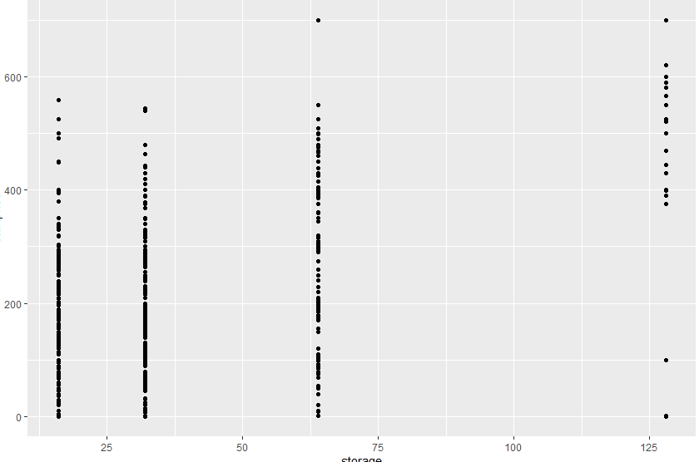

|  |
| --- |
| > #### Visualization ###  > # Load the necessary package  > library(ggplot2)  > # Create a scatter plot between startprice and storage  > ggplot(p, aes(x = storage, y = startprice)) +  + geom_point()  > # In the above plot, add the color argument which should be dependent on the sold Variable  > ggplot(p, aes(x = storage, y = startprice, color = sold)) +  + geom_point() |
|  |
| |  | | --- | | > | |

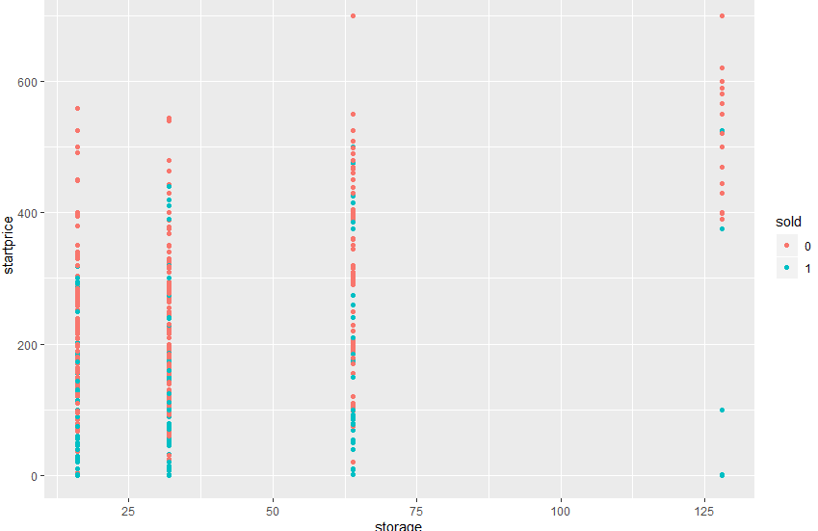

> # In the above plot where you had used the color argument, please add the smooth line using the geom_smooth() function

> ggplot(p, aes(x = storage, y = startprice, color = sold)) +

+ geom_point() +

+ geom_smooth()

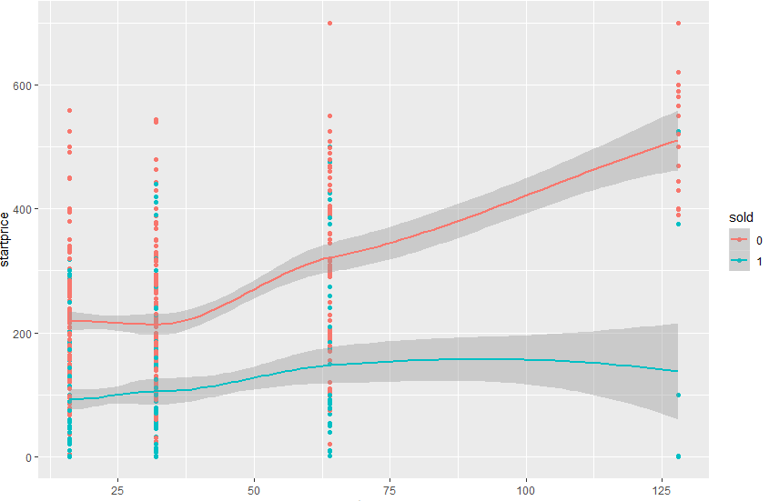

> ggplot(p, aes(startprice)) +

+ geom_histogram()

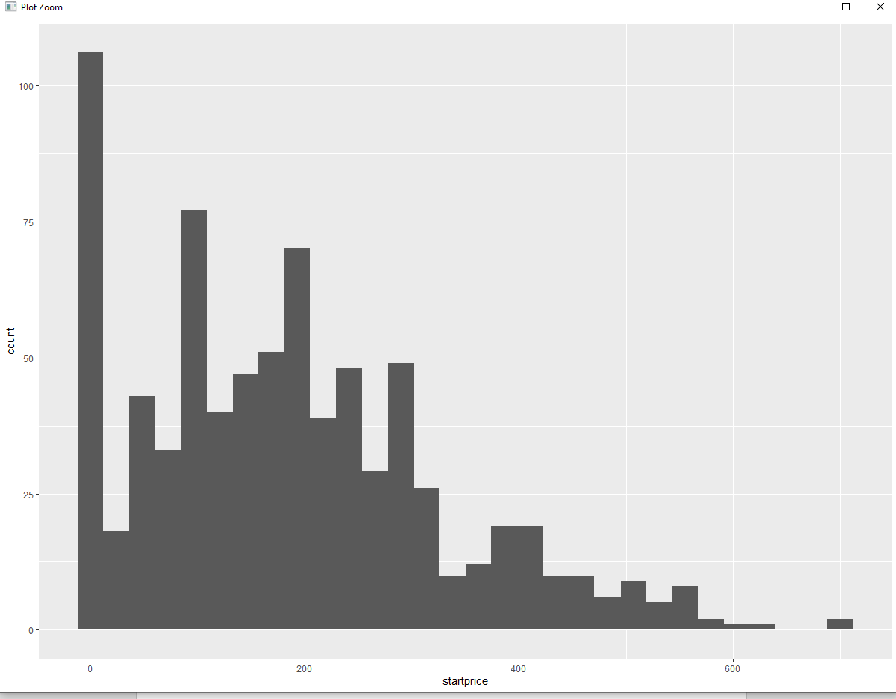

ggplot(p, aes(startprice)) +

geom_histogram(binwidth = 200)

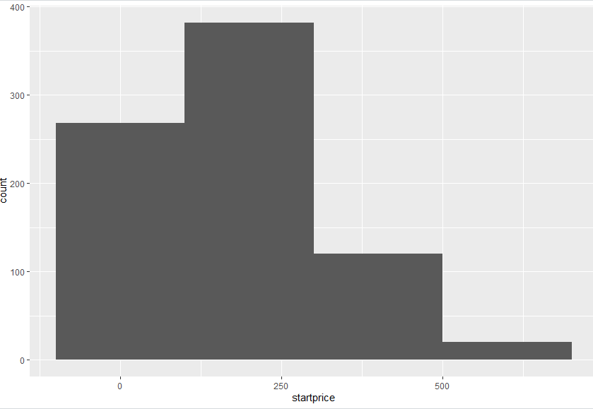

> ggplot(p, aes(startprice)) +

+ geom_histogram(aes(y = ..density..), binwidth = 200)

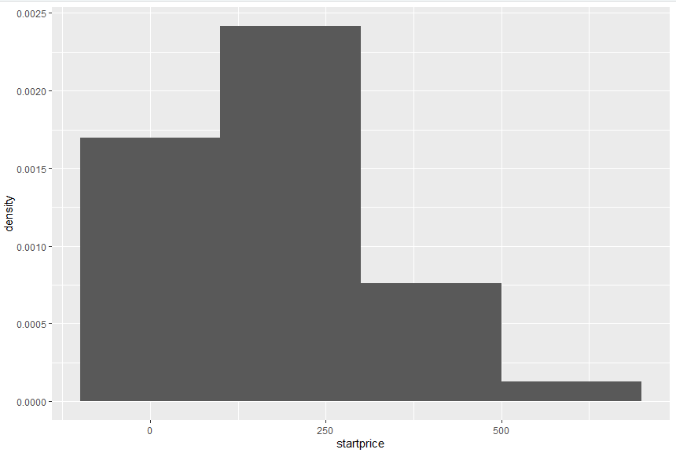

> ggplot(p, aes(startprice)) +

+ geom_histogram(aes(y = ..density..), binwidth = 200, fill = "#377EB8")

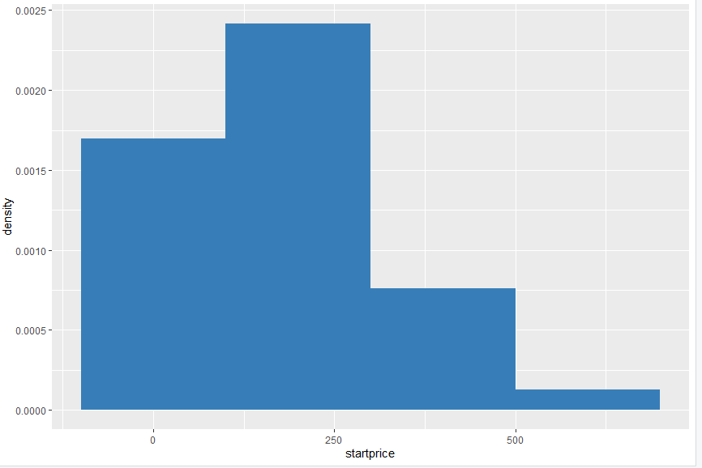

> ggplot(p, aes(x = sold, fill = biddable)) +

+ geom_bar()

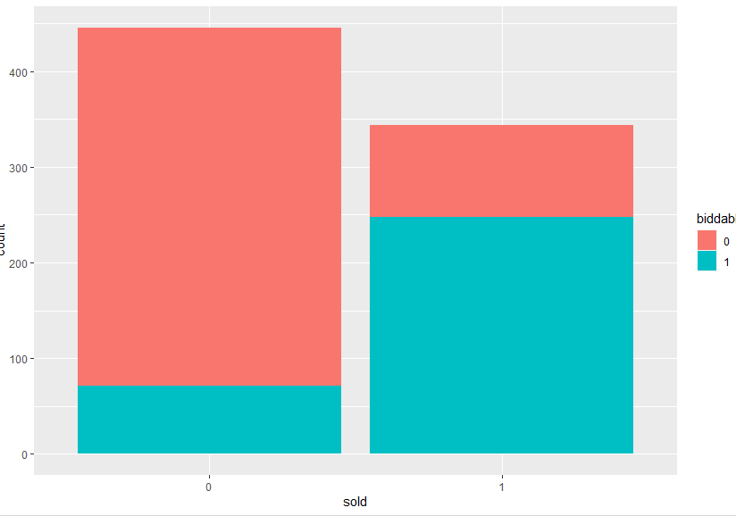

> ggplot(p, aes(x = sold, fill = biddable)) +

+ geom_bar(position = "fill")

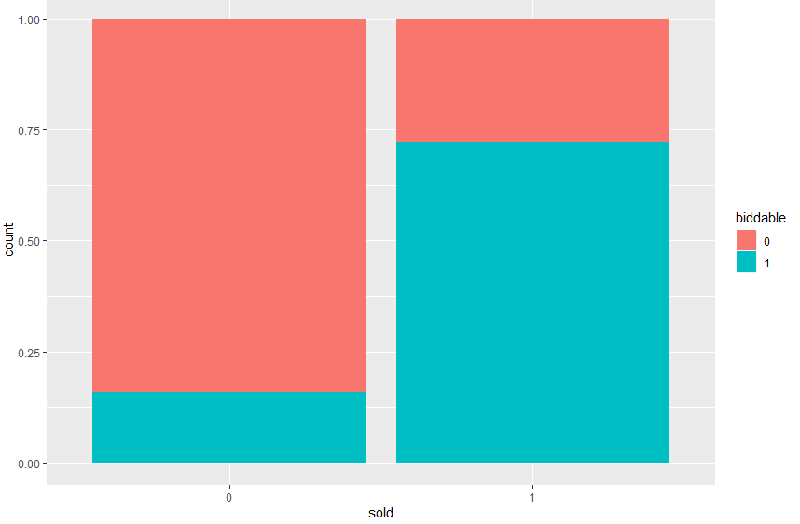

> ggplot(p, aes(x = sold, fill = biddable)) +

+ geom_bar(position = "dodge")

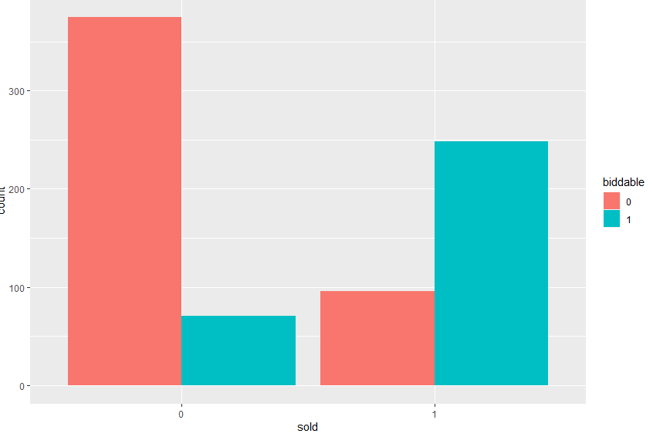

> p2 <- ggplot(p, aes(x = storage, y = startprice)) +

+ geom_point()

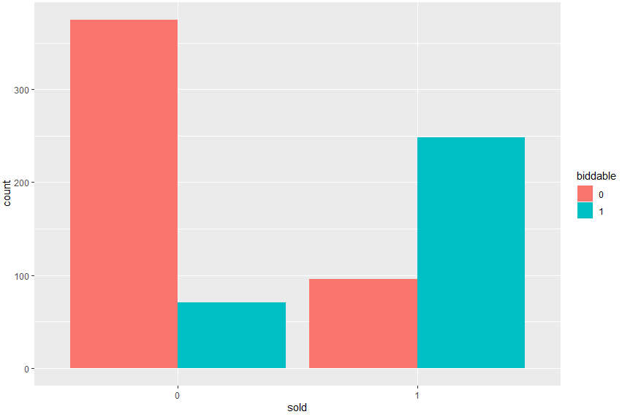

> p2 +

+ facet_grid(sold ~ .)

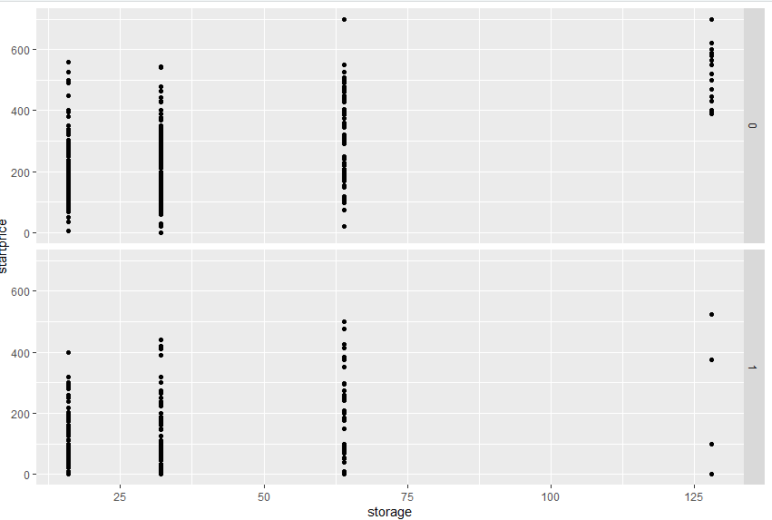

> p2 +

+ facet_grid(. ~ biddable)

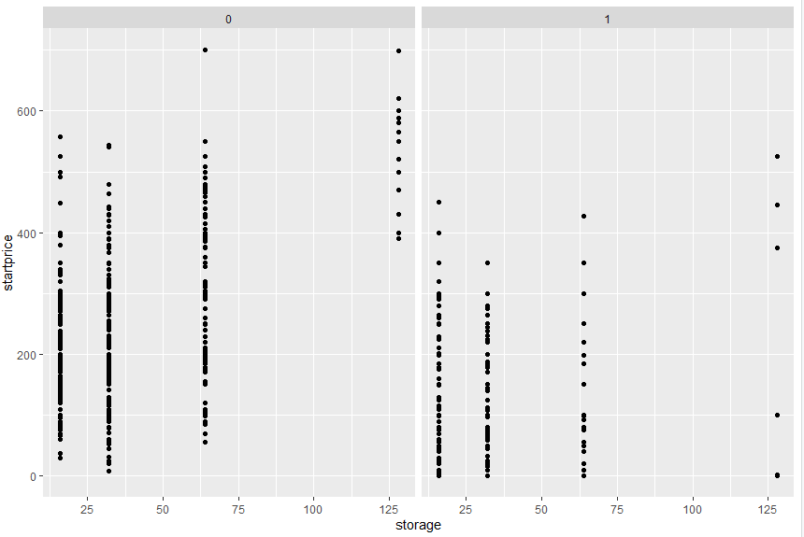

> ### Text Analytics ###

> #load the required packages and libraries

> library(tm)

> library(SnowballC)

> library('stringr')

> library('readr')

> library('wordcloud')

> library('tm')

> library('SnowballC')

> library(DT)

> #Now, extract the relevant variable, the one containing the text.

> r1 = as.character(p$description)

> #Set the seed to 100 for code reproducibility

> set.seed(100)

> # run the following command, 'sample = sample(r1, (length(r1)))', in your RStudio, now you are ready for Bag of Words

> sample = sample(r1, (length(r1)))

> # Create a Corpus - which, in simple terms, is nothing but a collection of text documents.

> corpus = Corpus(VectorSource(list(sample)))

> # Now, remove punctuations

> corpus = tm_map(corpus, removePunctuation)

Warning message:

In tm_map.SimpleCorpus(corpus, removePunctuation) :

transformation drops documents

> # Next, change the case of the word to lowercase so that same words are not counted as different because of lower or upper case.

> corpus = tm_map(corpus, content_transformer(tolower))

Warning message:

In tm_map.SimpleCorpus(corpus, content_transformer(tolower)) :

transformation drops documents

> # Next, remove numbers

> corpus = tm_map(corpus, removeNumbers)

Warning message:

In tm_map.SimpleCorpus(corpus, removeNumbers) :

transformation drops documents

> # Next, remove whitespaces

> corpus = tm_map(corpus, stripWhitespace)

Warning message:

In tm_map.SimpleCorpus(corpus, stripWhitespace) :

transformation drops documents

> # Now, remove unhelpful terms, also referred as stopwords

> corpus = tm_map(corpus, removeWords, stopwords('english'))

Warning message:

In tm_map.SimpleCorpus(corpus, removeWords, stopwords("english")) :

transformation drops documents

> # Now, please carry out the process of stemming, motivated by the desire to represent words with different endings as the same word.

> corpus = tm_map(corpus, stemDocument)

Warning message:

In tm_map.SimpleCorpus(corpus, stemDocument) :

transformation drops documents

> # creat a document term matrix from the corpus

> frequencies = DocumentTermMatrix(corpus)

> # now create the data frame from the output of the above line

> alldescription = as.data.frame(as.matrix(frequencies))

> # Create a word cloud and set random.order = TRUE:

> wordcloud(colnames(alldescription), colSums(alldescription), random.order=TRUE)

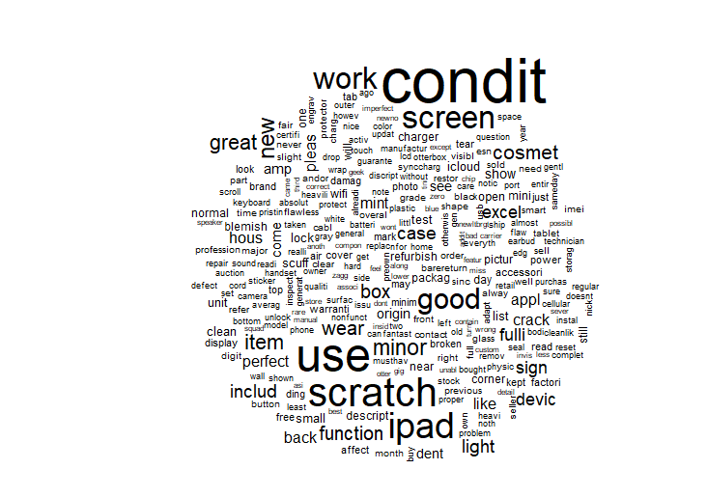

> wordcloud(colnames(alldescription), colSums(alldescription), random.order=FALSE)

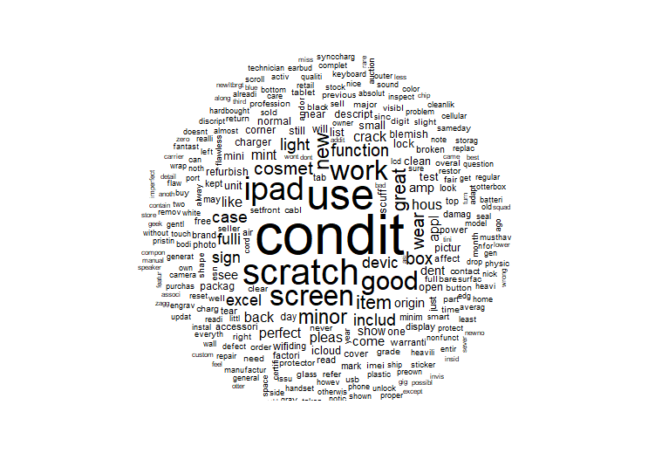

> wordcloud(colnames(alldescription), colSums(alldescription), random.order=FALSE, min.freq=5)

> ##### Creating Word Cloud for Soldipads ####

> #craete a new dataframe from the original data 'p' which only includes those observations where the ipad was not sold

> notsoldipads = subset(p, sold == 0)

> #extracting relevant negative tweets as character

> n1 = as.character(notsoldipads$description)

> #Set the seed to 100 for code reproducibility

> set.seed(100)

> #sample

> sample2 = sample(n1, (length(n1)))

> #Bag of Words - Run the above codes

> #1 - Create a Corpus

> #2 - Remove punctuations

> #3 - Convert to lowercase

> #4 - Remove Numbers

> #5 - Remove whitespaces

> #6 - Remove stopwords

> #7 - Perform Stemming

> corpus2 = Corpus(VectorSource(list(sample2)))

> corpus2 = tm_map(corpus2, removePunctuation)

Warning message:

In tm_map.SimpleCorpus(corpus2, removePunctuation) :

transformation drops documents

> corpus2 = tm_map(corpus2, content_transformer(tolower))

Warning message:

In tm_map.SimpleCorpus(corpus2, content_transformer(tolower)) :

transformation drops documents

> corpus2 = tm_map(corpus2, removeNumbers)

Warning message:

In tm_map.SimpleCorpus(corpus2, removeNumbers) :

transformation drops documents

> corpus2 = tm_map(corpus2, stripWhitespace)

Warning message:

In tm_map.SimpleCorpus(corpus2, stripWhitespace) :

transformation drops documents

> corpus2 = tm_map(corpus2, removeWords, stopwords('english'))

Warning message:

In tm_map.SimpleCorpus(corpus2, removeWords, stopwords("english")) :

transformation drops documents

> corpus2 = tm_map(corpus2, stemDocument)

Warning message:

In tm_map.SimpleCorpus(corpus2, stemDocument) :

transformation drops documents

> #creat a document term matrix from the resultant corpus

> frequencies2 = DocumentTermMatrix(corpus2)

> # now create the data frame from the output of the above line

> notsold = as.data.frame(as.matrix(frequencies2))

> wordcloud(colnames(notsold), colSums(notsold), random.order=TRUE)

> wordcloud(colnames(notsold), colSums(notsold), random.order=FALSE)

> wordcloud(colnames(notsold), colSums(notsold), random.order=FALSE, min.freq=5)

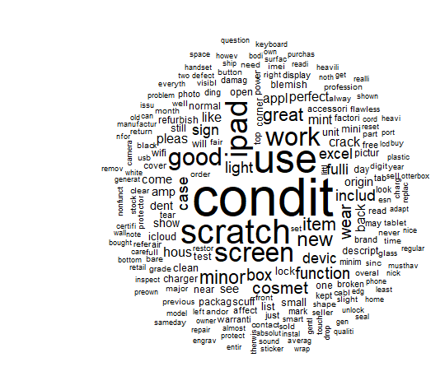

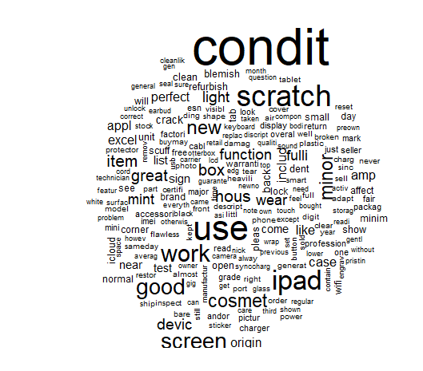

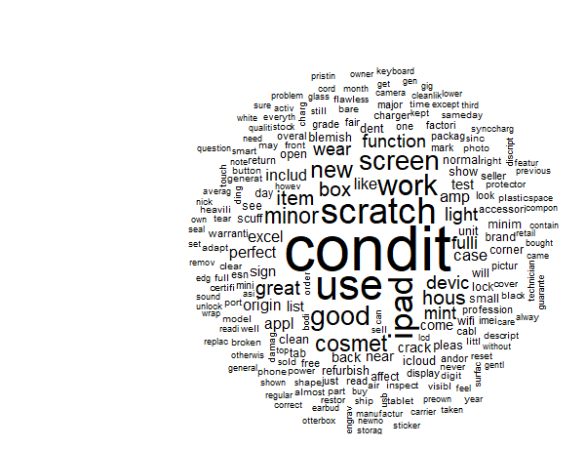

##### Creating Word Cloud for sold ipads ####

#craete a new dataframe from the original data 'p' which only includes those observations where the ipad was sold

p_sold = subset(p,sold == 1)

#Now, run the follwoing commands in your R Studio

#extracting relevant positive tweets

p1 = as.character(p_sold$description)

#Set the seed to 100 for code reproducibility

set.seed(100)

#sample

sample3 = sample(p1, (length(p1)))

> corpus3 = Corpus(VectorSource(list(sample3)))

> corpus3 = tm_map(corpus3, removePunctuation)

Warning message:

In tm_map.SimpleCorpus(corpus3, removePunctuation) :

transformation drops documents

> corpus3 = tm_map(corpus3, content_transformer(tolower))

Warning message:

In tm_map.SimpleCorpus(corpus3, content_transformer(tolower)) :

transformation drops documents

> corpus3 = tm_map(corpus3, removeNumbers)

Warning message:

In tm_map.SimpleCorpus(corpus3, removeNumbers) :

transformation drops documents

> corpus3 = tm_map(corpus3, stripWhitespace)

Warning message:

In tm_map.SimpleCorpus(corpus3, stripWhitespace) :

transformation drops documents

> corpus3 = tm_map(corpus3, removeWords, stopwords('english'))

Warning message:

In tm_map.SimpleCorpus(corpus3, removeWords, stopwords("english")) :

transformation drops documents

> corpus3 = tm_map(corpus3, stemDocument)

Warning message:

In tm_map.SimpleCorpus(corpus3, stemDocument) :

transformation drops documents

> #creat a document term matrix from the resultant corpus

> frequencies3 = DocumentTermMatrix(corpus3)

> # now create the data frame from the output of the above line

> soldipads = as.data.frame(as.matrix(frequencies3))